**Science Friction and More:**

**Revisiting the Derivation and Application of an Equilibrium Vacancy Rate**

*Richard L. Parli, MAI and Norman G. Miller, Ph.D.*

**Introduction**

The primary measure of a real estate market’s health is frequently expressed in one number – the vacancy rate. A high vacancy rate is bad; a low vacancy rate is good. High and low, however, are relative terms and, to have meaning, must be compared to something; in other words, put into context. The context for a market vacancy rate is the equilibrium vacancy rate.

An equilibrium vacancy rate is that rate which produces no upward or downward pressure on rents. Since disequilibrium is manifested by rising or falling rents, it stands to reason that equilibrium should be characterized by stable rents. Comparing a market’s actual vacancy rate with the equilibrium vacancy rate will reveal the condition of that market and can indicate the future movement of rents.

A few questions arise related to the notion of an equilibrium vacancy rate. Is it different in different markets? Does it change over time? This paper will present evidence that the equilibrium rate is different for different markets and may be different if measured over different time periods. In this regard we find that equilibrium vacancy rates in recent cycles are similar to those discussed in the prior literature by Pyhrr et al (1990) and Mueller (1999) and others, even though the recent cycle trough (2009-2010) was characterized as one with much less over supply than in previous cycles.

The purpose of this paper is therefore threefold: 1) To explore the concept of equilibrium vacancy; 2) to propose a method of equilibrium vacancy rate measurement; and, 3) to explore the applications of equilibrium vacancy as observed in a sample of office markets.

**Market Equilibrium as Defined in the Literature**

Considering its importance to real estate market analysis, the concept of market equilibrium is given little attention in the literature. Generally, market equilibrium is referenced as simply the point where demand and supply are equal. Often it is treated as if the meaning is self-evident. For example, Fanning identifies step five of the Six Step Process as “Analyze Market Equilibrium or Disequilibrium” without defining either term.[1]

The Dictionary of Real Estate Appraisal defines *market equilibrium* this way:

The theoretical balance where demand and supply for a property, good, or service are equal. Over the long run, most markets move toward equilibrium, but a balance is seldom achieved for any period of time.[2]

The above definition seems to dismiss the relationship as merely “theoretical” and existing only when supply and demand are “equal.” If the word “equal” is taken literally, an equilibrium condition is a market without vacancy. But this conflicts with the concept of frictional vacancy where there is accommodation for the turnover of occupants and time required for search, contracting, tenant retrofits and moving. That frictional vacancy is a necessary condition – friction actually acting as a lubricant - may first have been identified by Hauser & Jaffe (1947) when they pointed out that the “continuous turnover in housing occupancy necessitates a minimum number of vacant units which may be described as frictionally vacant units.”[3] Hauser & Jaffe had built upon the work of Homer Hoyt (1933) who had identified time cycles in the Chicago market.

The association of idle assets in a market with an equilibrium condition was also identified by Milton Friedman (1968) while pointing out that there is some level of natural unemployment that is “consistent with equilibrium in the structure of real wage rates.”0F[4] This equilibrium relationship was extended to the real estate rental market in 1974, when Smith’s research concluded that there is some level of vacancy that is associated with market equilibrium, “at which rents are in equilibrium”.[5]

Smith’s later collaboration with Rosen showed empirically what was meant by rents being in equilibrium – that vacancy rate at which rent changes equal zero.[6] This has been expressed in various ways but with the same meaning: that rate of vacancy that provides landlords with no incentive to adjust rents (Jud & Frew 1990), (Mueller 1999) and others; the vacancy rate where effective demand is equal to effective supply (Clapp 1993); a market is in equilibrium when there is no tendency toward changes in prices or quantities (McDonald & McMillan 2011).

Stable rental rates are therefore a necessary condition of market equilibrium. If there is market disequilibrium due to excess supply, there will be downward pressure on rental rates, which stimulates demand for the vacant space. If the disequilibrium is due to excess demand, there will be upward pressure on rental rates until the demand is diminished (or additional space delivered). Since stable rental rates is the only indispensible condition associated with market equilibrium, market equilibrium can be defined as the relationship between demand and supply that produces stable rental rates. This is not a theoretical condition and is certainly not a condition that is seldom achieved.

**The Equilibrium Vacancy Rate Hypothesis**

Much of the research on market equilibrium has been performed with the expressed goal of proving something that appraisers generally take for granted: that rental rates respond to vacancy rates (the change in rent is the dependent variable). The goal of this research was often expressed as a study of the “price-adjustment mechanism” – i.e., what causes average rental rates to vary over time and across space? The consensus conclusion is that the rate of change in rents is partly determined by the deviation of short-run vacancy rates from their long-run or “normal” level, and partly due to market-wide inflationary/deflationary pressures. As more research has been completed, the role of vacancy has been generally accepted as the dominant influence on real rent change.

In short, the equilibrium vacancy rate hypothesis is that there must be a market vacancy rate where demand and supply are effectively equalized. As a corollary, the movement of rents in a market is inversely related to the vacancy rate of that market and movement away from equilibrium can produce either upward and downward pressure on rental rates. To date, the research on identifying a market’s equilibrium vacancy rate has been performed almost exclusively by the scholarly community.

**Building Upon the Prior Models of Rents as Impacted by Vacancy Rates**

With few exceptions, the scholarly literature provides empirical support for the existence of an equilibrium vacancy rate. The research has relied upon historical vacancy rates linked to published rental rates. There is no known way to forecast an equilibrium vacancy rate; it must be inferred or extracted from the historical record.

Rosen and Smith (1983) had a goal to uncover the components of the rent-adjustment mechanism for a particular property type (in their case, rental housing). Based on the hypothesis that excess supply or excess demand determines the rate of change of rent, Rosen and Smith expressed the rent adjustment mechanism as a function of operating expenses and vacancy:

*Rn = ƒ(E, Ve ̶ V)* (1)

where *Rn* is the rate of change of nominal rent, *E* is the rate of change of total operating expenses (intended to reflect the nominal price influences on *Rn*), *V* is the actual vacancy rate, and *Ve* is the equilibrium rate (which they called the *natural* *rate*). Assuming a constant equilibrium vacancy rate over the study period, the regression equation becomes:

*Rn = b0 – b1V + b2E*  (2)

Given that *b1* and *b2* are positive numbers, the equilibrium vacancy rate is determined by solving for *V* when *Rn* is zero. Although the practical application is limited, it is important to realize that the formula expresses the expectation that rent change in a market is a function of the interaction of multiple nominal price influences, plus the relationship of equilibrium vacancy with actual vacancy.

Virtually all subsequent studies used a rent change equation similar to (2). Wheaton and Torto (1988), however, simplified the equation by using real rent (as opposed to nominal rent) as the dependent variable, thereby (theoretically) eliminating the need to specifically include operating costs (on the theory that real rent would capture the inflationary/deflationary changes in operating costs). The resultant regression equation from this approach is as follows:

*Rr = b0 – b1V*  (3)

where *Rr* is the change in real rent. If *Rr* is zero, then the equilibrium vacancy rate is expressed by the following formula:

*Vn = b0 ÷b1* (4)

Over the years, the research has produced at least 15 published studies that estimated the equilibrium vacancy rate for many different communities and for many different time periods. The results range from 4.4% to 22.3%. All have relied upon historical data that was often up to a decade old. As the understanding of the cause of equilibrium vacancy advanced ̶ morphing from direct landlord control to pure market response ̶ the results presumably became more accurate and more credible through a refinement of the methodology. Although the studies may differ in methodology, they all agree that variations from the equilibrium vacancy rate is a primary cause of rent change; the degree of influence is the big difference among studies.

In summary, the scholarly research began with the goal of determining what combination of independent variables account for most changes in rent. As research evolved, the focus became how best to determine the vacancy rate that results in no change in rent. The typical derivation of the equilibrium vacancy rate has been to employ regression analysis. The evolution of the methodology has settled on Formula (3), relating the change in real rent to the level of vacancy.

**Additional Literature Reflecting on Equilibrium Vacancy**

The earliest, and one of the few, reference to an equilibrium vacancy rate in the market analysis literature is found in Clapp (1987).8 Referred to as “normal” vacancy, it was defined as the long run average vacancy rate in the local market, adjusted “to reflect recent information on interest rates and expected demand growth.” F[7]

Anthony Downs did considerable research concerning the vacancy that impacts the housing and office markets. In *Cycles in Office Space Markets* (1993) he recognized that construction of new space was linked to an “equilibrium vacancy rate”, stating that an imbalance due to oversupply “will cause a cessation of new construction projects.”11F[8] Glenn Mueller extended and commercialized such analysis in his widely disseminated cycle reports by property type and market in his Cycle Monitor.[9]

Fanning, Grissom and Pearson (1994) provide three case studies and each one references a 5% *frictional* rate based upon “the industry rule-of thumb.” This rate is “employed in estimating proposed construction (i.e., justifiable building space) and in analyzing market equilibrium.”12F[10] By implication, it can be concluded that the 5% frictional vacancy rate was equated to the equilibrium vacancy rate.

Geltner, Miller, et al (2007) identify vacancy as an “equilibrium indicator.” While acknowledging that “it is normal for some vacancy to exist,” they make it clear that this normal vacancy is not necessarily related to an equilibrium condition. The equilibrium condition, instead, is associated with what they called the *natural vacancy rate*,

“the vacancy rate that tends to prevail on average over the long run in the market, and which indicates that the market is approximately in balance between supply and demand.”

Geltner, Miller, et al, also propose that the “natural vacancy rate is not the same for all markets” and that “the actual vacancy rate will tend to cycle over time around the natural rate.”[11]

Fanning (2005) mirrors Fanning, Grissom and Pearson (1994) in implying that a 5% frictional vacancy rate equates to the equilibrium vacancy rate. Our results like those of Mueller suggest something much higher depending on the cycle and the market.

In summary, there is agreement among market analysts on a commercial real estate market’s need for vacant space to operate efficiently. Beyond that, there appears to be little agreement on whether the needed vacancy is associated only with friction or also with an equilibrium condition.

**Derivation of an Equilibrium Vacancy Rate**

On a practical level, appraisers and market analysts should have the ability to extract an equilibrium vacancy rate from their local market for any property type. The proper use of inferential statistics will then permit extrapolation for predictive purposes. The question to be answered is how can this be done in a reliable manner with readily available information sources? The published research has emphasized two main methods – regression analysis using rent as a dependent variable; and the market analysis method of averaging the vacancy rate over an extended period. We will employ both of these methods, and test a third approach – graphic interpretation of the movement of vacancy rates and rental rates.

We have chosen nine markets to study: three cities on the west coast, three cities on the east coast, and three cities in the central part of the United States. In all cases, the equilibrium vacancy rate of the city’s Class A office space is the subject of analysis.

We have relied upon Costar data to perform our study.[12] Although none of the earlier research indicated a proper study period, we have tried to normalize the period covered over the cities tested, going back to no earlier than 1996 (depending on availability of information) and going forward through the fourth quarter 2013. We note that the behavior of each market must include both periods of rent change and/or periods of rent stability. If there is no evident period of stability, then there must be periods of both upward and downward movement in rents. A time frame that does not produce a balanced sample of market behavior will produce misleading results.

A summary of input data for this study is presented below in Exhibit 1:



Additional notes on the data:

* CoStar reports that the relevant definitions, including vacancy rate and direct average rent, have not changed over the study periods
* Direct Average Rent is the asking “face” rent for all vacant space in the office buildings offered by the property landlord (sublets excluded). Not all buildings were reporting direct rents for every quarter.
* Occupied space that is offered for lease is excluded from vacancy consideration

Ideally, net effective market rent would be tracked instead of asking face rents. However, reliable quantification of effective market rents over time is impractical. Asking face rents are used as a proxy in this research, but done so with the caution. Geltner, Miller, et al, (2007) identified the weakness of this approach:

*asking rents*, which may typically be reported in surveys of landlords, may differ from the *effective rents* actually being charged new tenants. The concept of effective rent includes the monetary effect of concessions and rent abatements that landlords may sometimes offer tenants to persuade them to sign a lease.[13]

A market just turning downward from an equilibrium condition pure would likely first invoke concessions before actually having asking face rents decline; similarly, a recovering market just turning upward would likely shed the concessions before increasing asking face rents. Ultimately, if a condition persists, downward pressure will prevail in forcing face rents down and upward pressure will prevail in forcing face rents up, evidencing a movement around equilibrium. All previous research has also been hampered by these possibly off-setting limitations.

**Derivation 1 – Regression of Rent and Vacancy Rate**

In hopes of diminishing the effect of inflationary/deflationary pressure of operating expenses on market rent, real rents have been chosen for use as our first dependent variable in the regression model. This approach postulates that real, as opposed to nominal rent change, is a pure function of the deviation of the actual vacancy rate from the equilibrium vacancy rate.

Nominal rents have been deflated by the Consumer Price Index for each city.[14]

We will use the Wheaton and Torto equation to test the relationship of real rents (dependent variable) with the market vacancy rate (independent variable), shown below:

*Rr = b0 – b1V* (3)

where *Rr*  is the change in real rents and *V* is the corresponding vacancy rate.

The equilibrium vacancy rate will be the quotient of the estimated constant term (intercept) in the regression equation divided by the estimated independent variable coefficient.

*Ve = b0  ÷ b1* (4)

The regression of the quarterly observations of average real rent and the corresponding reported vacancy rate for each city produced the following results in Exhibit 2 below:



For all cities, the intercept and variable coefficients are significant at the 5% level. The coefficients of determination (R2) range from an unreliable 0.01467 (Seattle) to a fairly reliable 0.4435 (San Diego).

In theory, using real rent would ideally eliminate the influence of inflation/deflation on the movement of rental rates. This is predicated on the assumption that rental rates are noticeably affected by changes in the CPI, Consumer Price Index. Since it is actually nominal rents that respond to contemporaneous changes vacancy rates, we tested this relationship as well. We will use a variation of the Wheaton and Torto equation to test the relationship of nominal rents (dependent variable) with the market vacancy rate (independent variable), shown below:

*Rn = b0 – b1V* (5)

where *Rn* is the change in nominal rents and *V* is the corresponding vacancy rate. Exhibit 3 below shows the results with nominal rents.



Again, for all cities, the intercept and variable coefficients are significant at the 5% level. The coefficients of determination (R2) are consistently higher, as are the t-statistics, for both the intercept and the variable. It might be the case that the CPI is a poor measure of inflation and simply adds noise to the results.

Under both the real and nominal relationships we tested lagged vacancy rates to determine if the market registered a delayed response to a vacancy rate. This is based on the possibility that variations in vacancy rates may affect average rents with a lag. There is no standard lag period, but most studies have used 6-months, possibly because that was the periodic spacing of their data. We employed one-quarter lag using Formulas (3) and (5) modified, as shown below:

*Rr/n = b0 – b1Vt-1* (6)

where *Vt-1* is the actual vacancy rate delayed one period.

Using formula (6), we regressed the real and nominal rent for each city and determined that there were no significant change in the results (equilibrium rent similar with no noticeable improvement in R2s).

We conclude that the results of regressing nominal rent with contemporaneous vacancy are superior to regressing real rent with contemporaneous vacancy; these results are also superior to regressing either nominal or real rent with delayed vacancy.

**Derivation 2 – Long Run Average Vacancy Rates**

This approach de-links the rental rate from the vacancy rate, and focuses only on the vacancy rate. In order for this approach to produce credible results, the data set must demonstrate sufficient fluctuation – i.e., it must have segments of a down market (increasing vacancy rates and declining rental rates) as well as segments of an up market (decreasing vacancy rates and increasing rental rates). We calculated both the mean and the medium over the study period for each city. The results are shown below in Exhibit 4:



The consistent similarity of the median to the mean is interpreted as indicating that the samples approximate a symmetric distribution and that the data meets the fluctuation criteria.

Clapp (1987) recommended that the average vacancy rate be “a reasonable starting point for estimating the normal [equilibrium] vacancy rate.”[15] He recommended adjusting the average to reflect recent information on interest rates and expected demand growth. This implies that the rate is not constant over time and that its applicability to the future could be affected by a change in market conditions not adequately represented in the data set. This might be the case if the survey period is as short as the five- or ten-year period (the time frame referenced by Clapp). In the present case, however, the extended time frame for each city included a wide range of demand influencing factors, including a range of interest rates and growth, and therefore no adjustment would be appropriate going forward.

**Derivation 3 – Graphic Interpretation**

In graphic interpretation, the independent variable for each city are the observed quarters and there will be two dependent variables: 1) average full service nominal rent per square foot; and, 2) the actual occupancy rate. We have used the occupancy rate in order to show the positive correlation between rent and occupancy. Representations of the results are shown below in Exhibits 5A (Atlanta) and 5B (San Diego):

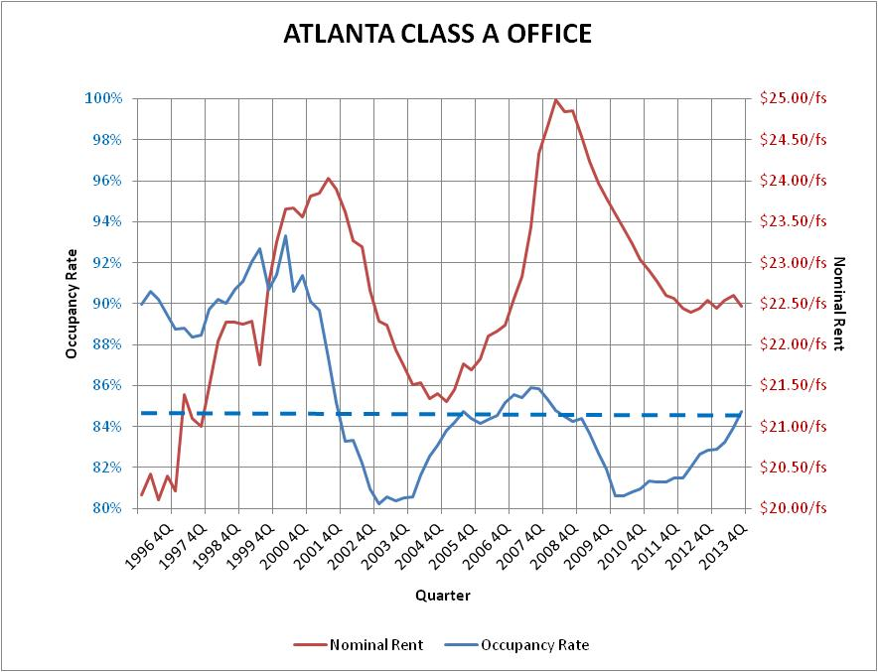

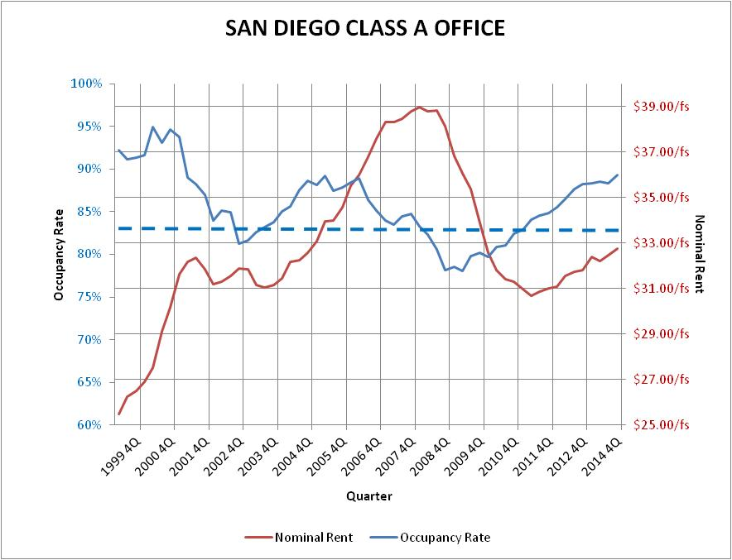

None of the graphs present a definitive picture of the positive relationship between occupancy rates and rental rates over time. However, the lead appears to be closer to 3 quarters for San Diego and 2 quarters for Atlanta. In the Atlanta market, shown above, we observe an increase in rents until the occupancy rate drops below 85%, at which point rents drop until the vacancy rate increases above 85%, which triggers a steep climb in rents. This would indicate an equilibrium vacancy rate of about 15% for the Atlanta Class A office market. A similar interpretation of the San Diego market can be made, but with the point of inflection being about 83% occupancy, indicating an equilibrium vacancy rate of about 17% for the San Diego Class A office market.

**Summary of Derivation Results**

The results of our analysis are summarized in the following table, Exhibit 6



The three equilibrium rate indicators for each city are very similar across the board. On an individual city basis, each test appears to confirm and reinforce the others. The mean vacancy rate for each city is very close to the regression results, both using nominal rent and real rent. However, the correlation is greatest with the nominal rental rate.[16] The graphs generally support the mean vacancy rate as a visual confirmation of a market’s equilibrium vacancy rate. Geltner, Miller, et al (2007) concluded that the regression process may not produce reliable results if net effective rent is used, stating that “real [net effective] rents reflect the actual physical balance between supply and demand in the space market.”[17] By using the mean vacancy rate, this deficiency is eliminated.

An additional issue with the regression approach may be serial correlation. Serial correlation occurs in time-series studies when the errors associated with a given time period carry over into future time periods. This is most likely present in this test (as well as in all the previous scholarly work).

We conclude that the long run average (or *natural*) vacancy rate can be a reliable indicator of the equilibrium rate for any given market, as long as adequate fluctuation over an extended period has been experienced by the market.

**The Utility of the Equilibrium Vacancy Rate**

Although there has been extensive research on measuring equilibrium vacancy, very little guidance has been provided on how to use it. What is implied throughout prior research work generally, however, is that equilibrium vacancy, since it is the portion of supply that is unoccupied in a balanced market, is a supply side consideration.

Equilibrium vacancy is market specific and is extracted from a market based on that market’s existing supply and the ability of each market to respond to changes in demand. We expect that markets with more supply constraints will also reveal greater volatility in rents over the course of a cycle and also lower correlations between rents and vacancies since the time period required to add new supply can be so unpredictable.

Assume market research revealed that the local market’s equilibrium vacancy rate is 10% for Class A office space. How this rate is applied will impact the results of a market study. Assume the following inputs result in the following calculations shown in Exhibits 6A and 6B:

**A. Marginal Demand Analysis**

Demand

Current Employed Workforce 20,000

% of above in Class A Buildings 35%

7,000

Average sf per worker 250

Demand for Class A Space (sf) 1,750,000

Supply

Current Existing Class A Space (sf) 2,000,000

Less Equilibrium Vac @ 10% 200,000

Supply net of Equilibrium Vac. (sf) (1,800,000)

Deficiency of Demand (sf) 50,000

**B. Marginal Supply Analysis**

Demand

Current Employed Workforce 20,000

% of above in Class A Buildings 35%

7,000

Average sf per worker 250

Demand for Class A Space (sf) 1,750,000

Load Equilibrium Vac @ 10% 194,444 Supportable Demand (sf) 1,944,444

Supply

Current Existing Class A Space (sf) (2,000,000)

Excess of Supply (sf) 55,556

What is most striking about the comparison of Exhibit 6A with 6B is not only the different amount of equilibrium vacancy (even though the equilibrium rate is the same), but the difference in the marginal results. For a market analyst, the results shown in 6A reveal 50,000 square feet of space must be absorbed for market equilibrium to be reached. This result can be obtained from 6 B, but only by multiplying the marginal supply amount by the reciprocal of the equilibrium rate (1 – Equilibrium Vacancy Rate). Without taking this extra step, the marginal number represents the amount of supply (55,556 sf) that must be eliminated in order to achieve market equilibrium. Interestingly, even though the calculations are different in 6B, if supply remains static, the market nonetheless must absorb 50,000 square feet of space to get to equilibrium and thus equilibrium vacancy is actually 200,000 square feet, as calculated in 6A.

**Valuation Implications**

Consider an office building that is 80% occupied in a market that is also 80% occupied. Suppose the results of a formal market analysis reveals that the market will grow to 95% occupancy in a linear manner over a five year forecast period, demand growing at 3% year. The equilibrium vacancy rate for this market has been determined to be 90%. Even though demand is expected to be positive from day one of the forecast period, rent increases should not be expected before the third year, when vacancy should be approaching the equilibrium rate. Guidance on the strength of the increase can be gained by studying past occurrences in the market. For example, Chicago most recently triggered a significant upward movement in rents in the 1st quarter 2007. See Exhibit 7 below. The growth continued for 10 quarters, and totaled about 11% growth in rents, or about 4.5% per year.

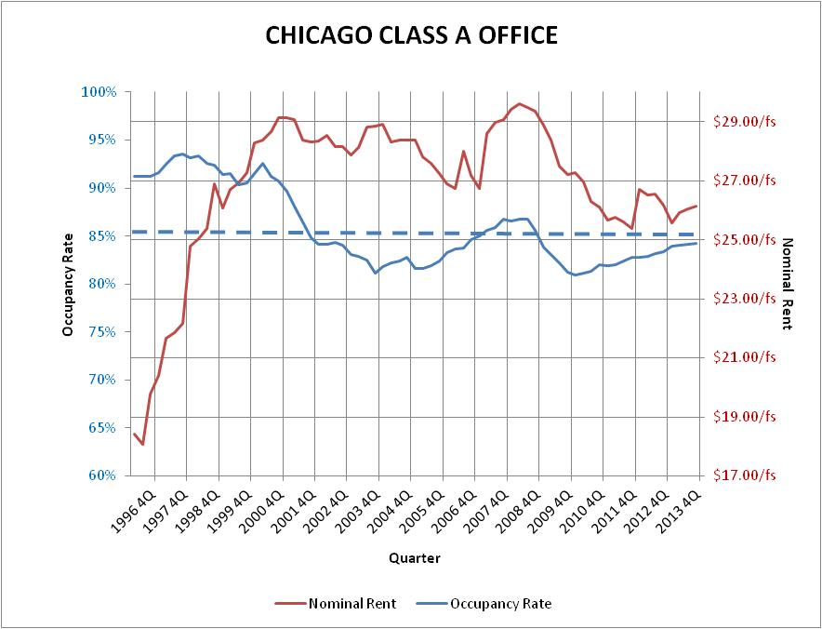

Financial feasibility is often associated with market equilibrium; that is, a market in equilibrium is presumed to be able to justify new construction. It is probably more accurate to say that a market vacancy rate above the equilibrium rate is strong indicator of a lack of financial feasibility and possibly external obsolescence. Of course, the financially feasibility of any one property must be determined on an individual basis, but inferences can be drawn from market conditions, Market conditions such as increasing rents, sales, and leasing activity, are often associated with demand in excess of market equilibrium, and thus a disequilibrium condition.

The appraisal literature generally avoids any discussion of stabilized occupancy for a market, focusing instead on the stabilized occupancy of a property. Consequently, frictional vacancy has often been identified as the vacancy defining a stable market. If a stable market is one with stable rental rates, then clearly equilibrium vacancy is the necessary ingredient. If a stable market is one that may be characterized by fluctuations in both rent and vacancy, but one that over time tends to return to equilibrium, then long run average market occupancy is represented by the residual of equilibrium vacancy from 100 percent.

**Conclusions**

Vacancy can and does significantly influence rent changes. Given that stable rents are a characteristic of market equilibrium, it follows that there must be some level of vacancy – the equilibrium vacancy rate – that produces stable rents. Vacancy in excess of this rate will produce downward pressure on rents; vacancy of less than this rate will produce upward pressure on rents.

We observe significant variations in equilibrium vacancy rates by market. Most analysts would consider that a 20% office vacancy rate indicates a market in distress. Yet, this research has shown that a 20% vacancy rate in Class A office space for the Dallas market approximates equilibrium. For the Atlanta Class A office market, the equilibrium vacancy rate is about 15%, much greater than most analysts would consider to be a healthy rate.

The equilibrium vacancy rate hypothesis is not in conflict with the presence of frictional vacancy. Accepting frictional vacancy as a necessary component only changes the numbers, not the relationship. For example, if frictional vacancy is assumed to be 5%, then demand equaling supply becomes 95% occupancy. Because search, contracting, and moving costs cause some vacancy in every market, a portion of the vacancy of the equilibrium condition is most certainly associated with friction.

Research reviewed in this paper is convincing that vacancy influences rental rates. Market observation, however, indicates that rental rates also influence vacancy. At a fundamental level, both rents and vacancy are responsive to economic demand for space. Demand absorbs vacant space to the point that rents are driven up, which stimulates new construction, which may drive average rents up (due to premium charged for new space) or down (due to an oversupply). This type of interrelationship can produce a small R2, but one that is nonetheless significant (at the 5% level). This suggests that the vacancy rate plays a significant role in rent changes. This role may become more prominent as the vacancy rate distances itself from the equilibrium level. The research could be skewed in this direction since the further away from equilibrium the vacancy rate gets, the less likely concessions are to mask changes in face rent.

Our research utilized three methods of extracting an equilibrium vacancy rate on a representative sample of nine Class A office markets. We conclude that an equilibrium rate is reliably and easily extracted from a market by simply determining the market’s mean vacancy rate over an extended period of time. Although we agree that inflationary/deflationary pressure on rents can cause market-wide movement, this issue and others are avoided by relying on the mean vacancy rate for an indication of the market’s equilibrium rate.

Knowledge of equilibrium vacancy is a valuable component of market analysis and valuation. Furthermore, once an equilibrium vacancy rate is identified in a market, it should be applied as extracted – against existing and forecasted supply. Doing so assures the correct understanding of a market’s current relationship to that of the long term equilibrium we are often told we are moving towards.

**REFERENCES**

Anari, M.A. & Hunt, Harold D., *Natural Vacancy Rates in Major Texas Office Markets,* Technical Report, Real Estate Center, November 2002.

Blank, David M. & Winnick, Lois, “The Structure of the Housing Market,” *Quarterly Journal of Economics*, May 1953, 67, pp. 181 – 203.

Carn, Neil, Joseph Rabianski, Ronald Racster, and Maury Seldin, *Real Estate Market Analysis, Techniques and Applications,* Prentice Hall, 1988.

Clapp, John M., *Handbook for Real Estate Market Analysis,* Prentice-Hall, Inc., 1987.

Clapp, John M., *Dynamics of Office Markets,* The Urban Institute Press, 1993.

Crone, Theodore M., “Office Vacancy Rates: How Should We Interpret Them?”, *Business Review*, Federal Reserve Bank of Philadelphia, May/June 1989.

Downs, Anthony, ”Cycles in Office Space Markets,” *The Office Building From Concept to Investment Reality,* Counselors of Real Estate, et al., 1993, pp. 153 – 169.

Eubank, Arthur A., Jr. & Sirmans, C.F., “The Price Adjustment Mechanism for Rental Housing in the United States” *Quarterly Journal of Economics,* February, 1979, pp. 163 – 168.

Fanning, Stephen F., *Market Analysis for Real Estate*, Appraisal Institute, 2005.

Fanning, Stephen F., MAI, Grissom, Terry V., MAI, PhD, Pearson, Thomas D., MAI, PhD., *Market Analysis for Valuation Appraisals,* Appraisal Institute, 1994.

Friedman, Milton, “The Role of Monetary Policy, *The American Economic Review*, Volume LVIII, Number 1, March 1968, pp. 1-17.

Gabriel, Stuart A. & Nothaft, Frank E., “Rental Housing Markets and the Natural Vacancy Rate”*, AREUEA Journal*, Vol 16, No. 4, 1988, pp. 419 – 429.

Geltner, David M., Miller, Norman G., Clayton, Jim, Eichholtz, Piet, *Commercial Real Estate Analysis & Investments*, Thomson South-Western, 2007.

Hagen, Daniel A. & Hansen, Julia L, “Rental Housing and the Natural Vacancy Rate,” *Journal of Economic Research*, Vol. 32, No 4, 2010, pp. 413 - 433.

Hauser, P.M. & Jaffe, A.M., “The Extent of the Housing Shortage,” *Law and Contemporary Problems*, Winter 1947, Vol. 12, Issue 1, pp. 3 - 15.

Hoyt, Homer, *100 Years of Land Values in Chicago: The Relationship of the Growth of Chicago to*

*the Rise in its Land Values*, 1830–1933, Chicago, IL: University of Chicago Press, 1933.

Jud, G. Donald & Frew, James, “Atypicality and the Natural Vacancy Rate Hypothesis”, *AREUEA Journal*, Vol 18, No. 3, 1990, pp. 294 – 301.

Krainer, John, *“*Natural Vacancy Rates in Commercial Real Estate” *FRBSF Economic Letter,* Federal Reserve Bank of San Francisco, No. 2001-27, October 5, 2001.

McDonald, John F., “Rent, Vacancy and Equilibrium in Real Estate Markets, *Journal of Real Estate Practice and Education,* Volume 3, Number 1, 2000, pp. 55 – 69.

McDonald, John F. & McMillen, Daniel P. *Urban Economics and Real Estate*, John Wiley & Sons, 2nd ed., 2011

Mueller, Glenn R. “Real Estate Rental Growth Rates at Different Points in the Physical Market Cycle” *Journal of Real Estate Research*, Vol 18: No. 1, 1999, pp. 131-150

____., Understanding Real Estate’s Physical and Financial Market Cycles, Real Estate

Finance, 1995, 12:1, 47–52.

Pyhrr, S. A., J. R. Webb and W. L. Born, Analyzing Real Estate Asset Performance During

Periods of Market Disequilibrium, Under Cyclical Economic Conditions, *Research in Real*

*Estate*, Vol. 3, 1990, JAI Press.

Rabianski, Joseph F., “Vacancy in Market Analysis and Valuation”, *The Appraisal Journal*, April 2002, pp. 191 – 199.

Rosen, Kenneth T. & Smith, Lawrence B., “The Price-Adjustment Process for Rental Housing and the Natural Vacancy Rate,” *The American Economic Review,* Vol. 73, No. 4, September 1983, pp. 779 – 786.

Shilling, James D., Sirmans, C.F. & Corgel, John B., “Price Adjustment Process for Rental Office Space”, *Journal of Urban Economics,* Vol. 22 (1), 1987, pp. 90 – 100.

Sivitanides, Petros S., “The Rent Adjustment Process and the Structural Vacancy Rate in the Commercial Real Estate Market”, *Journal of Real Estate Research*, Vol. 13, No. 2, 1997, pp.195 – 209.

Smith, Lawrence B., “A Note on the Price Adjustment Mechanism for Rental Housing”, *American Economic Review,* Vol. 64, No. 3, 1974, pp. 478 - 481

Thoma, Mark, “The Natural Vacancy Rate for Housing,” *Economist’s View*, blog, November 29, 2005.

Sumichrast, Michael “Housing Market Analyses,” as reprinted in *Readings in Market Research for Real Estate*, edited by James Vernor, Appraisal Institute, 1985, p. 69.

Voith, Richard & Crone, Theodore, “National Vacancy Rates and the Persistence of Shocks in the U.S. Office Markets”*, AREUEA Journal*, Vol 16, No. 4, 1988, pp. 437 – 458.

Wheaton, William C. & Torto, Raymond G. “Vacancy Rates and the Future of Office Rents”*, AREUEA Journal*, Vol 16, No. 4, 1988, pp. 430 – 436.

1. Fanning, Stephen F., MAI, Market Analysis for Real Estate, Appraisal Institute, 2005, p. 256.
2. Dictionary of Real Estate Appraisal, Appraisal Institute, 5th ed., p. 121.
3. Hauser, P.M. & Jaffe, A.J., “The Extent of the Housing Shortage”, Law & Contemporary Problems; Winter1947, Vol. 12 Issue 1, p3
4. Friedman, Milton, “The Role of Monetary Policy”, *The American Economic Review*, Volume LVIII, Number 1, March 1968, p. 8.
5. Smith, Lawrence B., “A note on the Price Adjustment Mechanism for Rental Housing”, *The American Economic Review*, June 1974, p. 481.
6. Rosen, Kenneth T. and Smith, Lawrence B., “The Price Adjustment Process for Rental Housing and the Natural Vacancy Rate”, *The American Economic Review*, September 2983, pp. 779 – 786.
7. Clapp, John M. Handbook for Real Estate Market Analysis*,* Prentice-Hall, Inc., 1987, p. 78
8. Downs, Anthony, ”Cycles in Office Space Markets,”  *The Office Building From Concept to Investment Reality,* Counselors of Real Estate, et al., 1993, p. 161.
9. See Dividend Capital Research at <http://www.dividendcapital.com/why-real-estate/market-cycle-reports/documents/Cycle_Monitor_12Q1_FINAL.pdf>
10. Fanning, Stephen F., MAI, Grissom, Terry V., MAI, PhD, Pearson, Thomas D., MAI, PhD., Market Analysis for Valuation Appraisals*,* Appraisal Institute, 1994, p. 241.
11. Geltner, David M., Miller, Norman G., Clayton, Jim, Eichholtz, Piet, Commercial Real Estate Analysis & Investments, Thomson South-Western, 2007, p. 105 -106.
12. The authors wish to express appreciation to Costar from providing invaluable assistance in this research.
13. Geltner, David M., Miller, Norman G., Clayton, Jim, Eichholt, Piet, Commercial Real Estate Analysis & Investments, Thomson South-Western, 2007, p. 106.
14. Charlotte is deflated at the regional level.
15. Clapp, John M., Handbook for Real Estate Market Analysis, Prentice-Hall, Inc., 1987, p. 78.
16. The correlation coefficient for the nominal rent paired with the mean vacancy rate is 0.9994 while the coefficient for the real rent paired with the mean vacancy rate is 0.8072.
17. Geltner, David M., Miller, Norman G., Clayton, Jim, Eichholtz, Piet, Commercial Real Estate Analysis & Investments, Thomson South-Western, 2007, p. 106.