**February 2013 Housing Market Update: Top Price Tier Submarkets Moving Up**

*By Michael Sklarz, CEO, Collateral Analytics and Norm Miller, Professor, Burnham-Moores Center for Real Estate, University of San Diego*

The outlook for the residential real estate market continues to improve. We have long held the view that real estate markets exhibit varying degrees of predictability with the accuracy steadily improving as more sales and internal market indicator data becomes available. Many of the interior U.S. markets exhibit low volatility and are relatively easy to forecast. Others on the East and West Coasts exhibit more volatility due to the combination of constrained supply and generally rising demand. Home prices in these markets rise and fall faster than in markets where new supply is more elastic such as the more open Midwest U.S.

One sector which we pay particular attention to is the market for higher priced homes. These tend to lead the overall market on both the upside and downside of the real estate cycle. Figure 1 below shows long-term historical home prices expressed per square foot of living area for several Los Angeles County markets. We chose these three markets as they are representative of low, average and high-priced cities within this metro. We have added arrows to highlight the inflection points over the past three cycles when prices began to accelerate on the upside. Note the clear pattern of the high-priced market moving first, followed by the average and then lower-priced ones. ***Most newsworthy is the latest up move in the Manhattan Beach market which has pushed prices to all-time high levels.*** This should be viewed as a confirmation that the L.A. County real estate market is in the early stages of a new upward-cycle in home prices.

The fact that higher priced markets tend to be market leaders is quite logical. These markets are usually situated in desirable and very supply constrained locations. In addition, buyers in these markets tend to be better capitalized using more equity and lower loan-to-value mortgages. The higher priced markets are less affected by the tight underwriting which has plagued the middle and lower price ranges where loan to value average are generally much higher. These higher priced markets are also highly informed. The borrowers know that mortgage rates are currently a bargain and they are taking advantage of the historically cheap credit. Last, these higher priced households are also more likely to have benefitted from the 13% average increase in the stock market in the last few quarters.

**Figure 1**

There are a number of other examples of higher priced markets which are exhibiting strong price performance over the past year. As seen in Figure 2, upscale cities in the Bay Area have been outstanding performers with a number having seen their average sold prices move up to all-time record levels. The Bay area economy has benefitted from the robust growth in the technology sector over the past year. This region’s home price rally has been ignored by most of the media who continue to focus on the distressed markets and the inventory of foreclosure and REO properties.

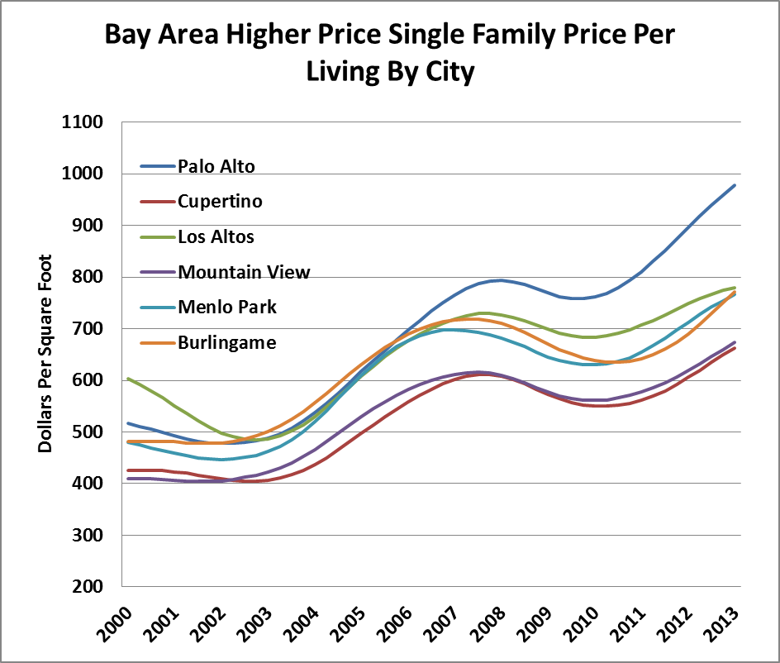

**Figure 2**

There are some very interesting trends between lower and higher priced homes even when we stay within the same market. Figure 3 below shows Palo Alto Single Family average sold prices for different size homes. Note how the largest and most expensive homes were the first to rise in the past year compared to the smaller and relatively less expensive ones. In addition, their rate of price appreciation has been much higher. Again, this suggests that high price homes are market leaders both across different markets as well as within the same market.

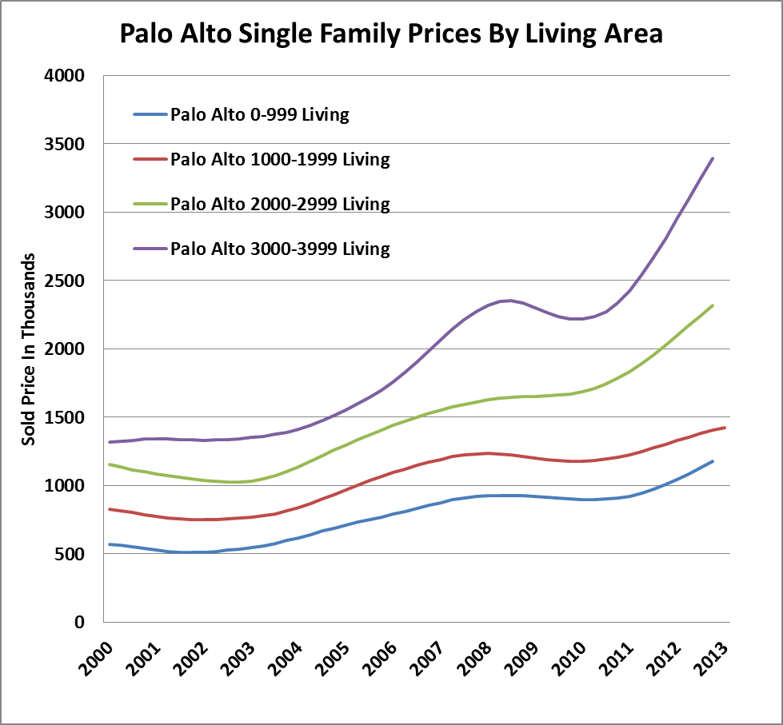

**Figure 3**

**CBSA Winners and Losers**

Each month Home Value Forecast ranks the single family home markets in the top 200 CBSAs to highlight the best and worst metros with regard to a number of leading real estate market based indicators.

The ranking system is purely objective and is based on directional trends. Each indicator is given a score based on whether the trend is positive, negative, or neutral for that series. For example, a declining trend in active listings would be positive as will be an increasing trend in average price. A composite score for each CBSA is calculated by summing the directional scores of each of its indicators. From the universe of the top 200 CBSAs, we highlight each month the CBSAs which have the highest and lowest composite scores.

The tables below show the individual market indicators which are being used to rank the CBSAs along with the most recent values and the percent changes. We have color-coded each of the indicators to help visualize whether it is moving in a positive (green) or negative (red) direction.

**Top 10 CBSAs**



The top ranked metros in the current month include markets from all major regions of the U.S. Three of the top markets are in Southern California and include the important Los Angeles and Orange County (Santa Ana-Anaheim-Irvine) CBSAs. Another two are located in Massachusetts and include the widely followed Boston-Quincy CBSA. A new entrant to the Top 10 list this month is Indianapolis-Carmel. Like a number of Mid-West markets, this is one which did not participate in the nationwide housing bubble and, thus, did not need to experience a significant price correction. In fact, Indianapolis home prices have been among the most affordable in the country for many years. The result is that this is another market which has very compelling rental yields which is apparently attracting both institutional and individual single family home investors. Such investment pools certainly exceed the available supply of distressed inventory as we enter into mid-2013. The distress investors to date have tended to go where the volumes of distress were highest, resulting in rapid declines in the discounts available on REO purchases and multiple buyers in the herd of investors trying to fill their quotas. This has benefitted markets like Phoenix and Sacramento who are no longer on the list.

Several of the top markets from late last year are no longer on the list because their year-over-year sales counts are down. However, the reason for this is that sales are being constrained by a lack of inventory rather than a decrease in demand. Note that all the indicators in the Top 10 list are colored green which means that they are universally exhibiting positive trends. One thing that all these markets have in common is that they all have experienced significant declines in active listing counts over the past year. Most of these currently having tight markets based on their Months of Inventory Remaining figures.

**Bottom 10 CBSAs**



The bottom ranked metros also represent and interesting mix with two being in the upstate New York area and two being in Louisiana. As seen in the table, most have high single or double-digit Months of Inventory Remaining. However, our top and bottom ranked CBSAs are ranked on a relative basis. Thus, even the ones in the Bottom 10 list are showing a fair percentage of positive (green) trends. This is quite different from last year when the majority of the Bottom 10 markets had most (or all) of their indicators trending negative and colored red.

Our Market Condition thematic maps are a good way to visualize the more geographically granular conditions within the metros. Figure 4 below shows zip code single family rankings for the Los Angeles-Long Beach-Glendale area.

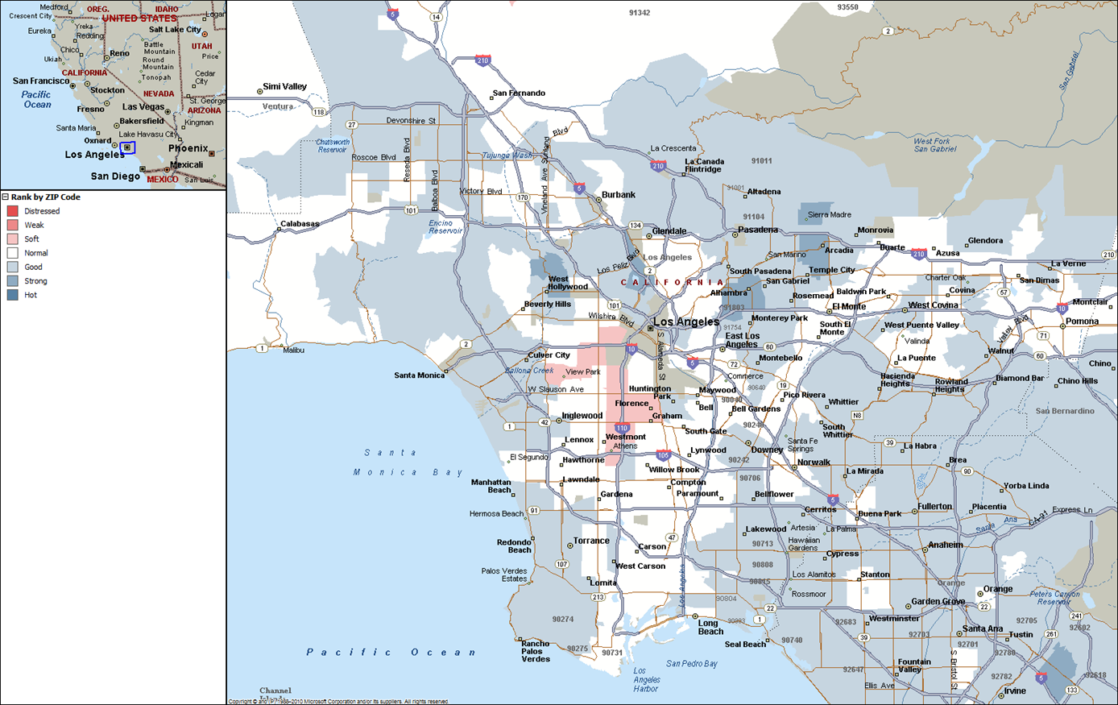

**Figure 4**

**Outliers**

In this month’s Outliers, we highlight the Los Angeles-Long Beach-Glendale, CA CBSA, which is currently in the list of the Top 10 metros. As seen in the ranking table above, all of its important market indicators for this CBSA are showing positive trends on a year-over-year basis including declining inventory, lower Inventory Remaining, declining market times and lower distressed sales activity to name a few.

Within the Los Angeles-Long Beach-Glendale CBSA there are numerous sub-markets. On a Zip code level, one of particular interest is Zip code 91108, San Marino, CA which is one of the higher priced markets which we discussed above.

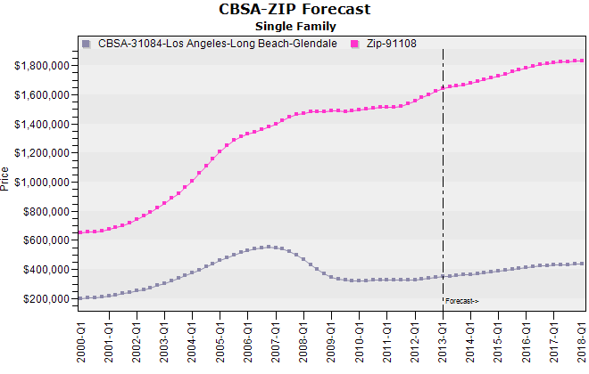

**Figure 5: CBSA – Los Angeles-Long Beach-Glendale | ZIP 91108, San Marino, CA**

As seen in Figure 5, single family home prices in this Zip code have moved completer counter to the Los Angeles metro since the market peak. In addition, as seen in Figure 5, our home price forecast models call for this Zip code to perform much better and move to all-time highs over the next several years.

There are a number of reasons for the historical and forecasted outperformance of this Zip code which include the fact that homebuyers in this Zip code have historically been better capitalized and, thus, better able to weather declines in home prices. The average loan-to-value (LTV) ratio in Zip 91108 has historically been below 70 percent compared to approximately 80 percent for the overall Los Angeles-Long Beach-Glendale, CA CBSA.

**About Home Value Forecast**

Home Value Forecast was created from a strategic partnership between Pro Teck Valuation Services and Collateral Analytics. HVF provides insight into the current and future state of the U.S. housing market, and delivers 14 market snapshot graphs from the top 30 CBSAs. Each month Home Value Forecast delivers a monthly briefing along with “Lessons from the Data,” an in-depth article based on trends unearthed in the data. HVF is built using numerous data sources including public records, local market MLS and general economic data. The top 750 CBSAs as well as data down to the ZIP code level for approximately 18,000 ZIPs are available with a corporate subscription to the service. A demonstration is available upon request. Please see [www.collateralanalytics.com](http://www.collateralanalytics.com) or see [www.protk.com](http://www.protk.com) for valuation services.