The Economics of Green Retrofits

|  |  |  |
| --- | --- | --- |
| Nils Kok Maastricht University n.kok@maastrichtuniversity.nl | Norm G. Miller  University of San Diego  nmiller@sandiego.edu | Peter Morris  Davis Langdon  pmorris@davislangdon.us |

**Abstract**

This is the first study focused on the economics of green renovations. With existing building renovation surpassing new construction in recent years, we now have sufficient data to perform statistical analyses on the economic impacts of retrofitting existing buildings Our findings are focused on LEED (Leadership in Energy and Environmental Design) buildings which became certified under the “EBOM” (Existing Building: Operations and Maintenance) certification scheme during the 2005 – 2010 period. We compare rents and occupancy rates, and investigate the types of improvements undertaken as well as the amount of investments required. We execute a survey among building owners on the typical improvements and attitudes towards the benefits and costs of upgrade investments. Our findings indicate that investments in “green” retrofits are incorporated by the market, which is consistent with past studies that mostly focused on new construction. The findings indicate that, on average, investments in the sustainability of commercial buildings are economically viable.

*JEL codes: G51, M14, D92*

October 1, 2012

Kok is supported by a VENI grant from the Dutch Science Foundation (NWO). We are grateful for the comments of two anonymous reviewers and participants at the 2011 USGBC Greenbuild Conference in Toronto, Canada. Michael Schuerman provided excellent research assistance.

1. **Introduction**

During the past several decades, the average new annual construction within the office market has been about 2.1 percent of the existing stock.[1] If all of this new construction were to be “green,” and if no renovation took place, it would thus take several decades to improve the energy efficiency and sustainability performance of the existing building stock.

To date there have been several studies focused on the sustainability of new office construction, as measured by the Leadership in Energy and Environmental Design (LEED) scheme, developed by the US Green Building Council. The certification scheme for Existing Buildings (“EBOM”) is of more recent vintage and with the dearth of new construction in the post-2007 commercial market downturn, certification of existing building renovations is now surpassing new construction certification rates. Exhibit I provides some evidence of the growth of LEED-certified space in the marketplace and the role of existing buildings therein. Quite clearly, there has been an explosive growth in LEED certification (see Panel A), with about ten percent of the US commercial office market certified at the end of 2010 (by square footage). Panel B shows that since 2009, LEED for Existing Buildings outpaces LEED for New Construction.

This is the first study to specifically address the economic implications of LEED certification (following a retrofit), extending the rapidly growing literature on the effects of “green” building in the marketplace. The data in this study is from CoStar and includes 374 LEED-certified properties (“EBOM”) and nearly 600 control properties for comparison purposes and empirical analysis. We also include a modest survey on the benefits and costs of retrofits. Many of the buildings in our sample were in the process of renovating to become more sustainable at the time the EBOM system was published. We identify the renovation period as generally starting in years 2005 through 2009 with certification received from 2008 through 2011.

The results show that the average rents on the “EBOM” group of buildings were below those of the control buildings prior to 2006, but have exceeded the average rents of the control buildings since 2006. Vacancy rates within EBOM-certified buildings were seven percent higher than the control group in 2005. Since 2005, the EBOM group has gained occupancy relative to the control buildings, but still lags slightly behind, primarily due to the soft real estate market since 2007. Using a regression analysis to control for class, age, location, size and distance to transit, we find a 7.1 percent rental premium for LEED buildings versus non-LEED buildings. When the Energy Star label is included we continue to find a significant premium for both Energy Star and LEED certification. The quantitative results, in combination with the survey evidence, provide important information for building owners and investors. There seems to be a tangible financial effect from LEED certification, which outweighs the costs of a retrofit.

1. **Literature Review**

Prior published literature on the financial implications of “green” certification mostly focuses on new construction within the U.S., and results generally indicate a positive relationship between environmental certification and financial outcomes in the marketplace. Eichholtz, Kok and Quigley (2010) document large and positive effects on market rents and selling prices following environmental certification of office buildings. Relative to a control sample of conventional office buildings, LEED or Energy Star-labeled office buildings’ rents per square foot are about two percent higher, effective rents are about six percent higher, and premiums to selling prices per square foot are as high as 16 percent. Other studies (Franz Fuerst and Patrick McAllister, 2011, Norm Miller et al., 2008) confirm these findings.

Importantly, these results appear robust over the course of the financial crisis, as Eichholtz, Kok and Quigley (2011) document for a recent dataset of 3,000 green buildings that both energy efficiency and “greenness” of buildings are capitalized into rents and sales prices. Moreover, this effect is not dented by the recent downturn in property markets. Other studies mention evidence suggesting positive economic benefits from faster absorption, higher occupancy rates, lower operating expenses, higher residual values as well as greater occupant productivity (Chi-Kwan Chau et al., 2010, F. Fuerst and P. McAllister, 2009, Norm Miller et al., 2009).

To date, there are no academic studies investigating the market performance of “green” renovations. There are numerous case studies of single buildings which have been retrofitted for the owner-occupant, but less so in the private rental market.[2]

Anecdotal evidence suggests that the move of tenants towards “green” real estate is due to enhanced reputation benefits, corporate social responsibility mandates and employee productivity (Andrew Nelson and A. J. Rakau, 2010). Such a shift in tenant preferences suggests that tenants are using the buildings that they occupy to communicate their corporate vision to shareholders and employees. The literature on corporate social responsibility (CSR) has generally investigated this link between corporate social performance, reputation benefits and employer attractiveness (J.D. Margolis and J.P. Walsh, 2003, D.B. Turban and D.W. Greening, 1997). In a recent broader study, Pivo and Fisher (2010) suggest higher rents and returns for those engaged in CSR.

Another frequently invoked rationale for occupying green office space is tenant productivity. Miller et al. (2009) document in a survey that over half of occupants of environmentally certified buildings found their employees to be more productive. Interpretation of these results is problematic, though, as these responses cannot control for management style and individual employee characteristics. However, surveys reporting on tenants in London indicate that there is indeed a shift in corporate preferences. A 2008 research report documents that 58 percent of tenants find energy efficiency “essential” and 50 percent find green attributes “essential.”[3] A 2012 survey of Corenet members suggests that tenants want natural light, better ventilation and better temperature control.[4] These features are consistent with more sustainable and greener space.

Improving the bottom line through building energy efficiency is often reported as one of the direct economic benefits for real estate investment companies when considering energy efficiency and sustainability in their portfolios. Jones Lang LaSalle reports that of 115 office properties in its portfolio for which the energy efficiency was improved in 2006, the average realized savings for 2007 and 2008 were $2.24 million and $3 million respectively.[5] British Land reports that across its portfolio, there is a reported 12 percent decrease in energy use, amounting to $1.12 million in annual savings in energy, and a decrease of 11.1 million kWh of energy used in 2009.[6]

Another stimulus for demand of sustainable space is government regulation and in many markets such as New York, San Francisco or Washington, D.C., we see increased government pressure both on the regulatory side (through mandatory disclosure) and from direct government office demand of the government services offices (the federal GSA as well as the California GSA) that require Energy Star or LEED labeled space for most new leases.

1. **Data**

Using CoStar data, we collect data on those markets where we observe the largest number of EBOM-certified office buildings, as of the first quarter of 2011. We apply the following filters: built prior to 1990; at least 15,000 square feet; multi-tenant; multiple floors; and Class A or B. This resulted in 374 office buildings certified under the Existing Building scheme, distributed over 14 markets, where there were at least 12 or more observations in any one market. The 14 markets include:

* New York City
* Washington, D.C.
* San Francisco
* Houston
* Los Angeles
* Chicago
* Seattle/Puget Sound
* Boston
* Orange County
* East Bay/Oakland
* Denver
* Atlanta
* Dallas/Ft. Worth
* Minneapolis/St. Paul

The 374 buildings are managed by 317 property managers (with some managers overseeing more than one building), to whom (structured) surveys were sent, inquiring into the types of improvements that were made to achieve LEED certification.

CoStar data on property details is used to perform the empirical analysis and to select a control sample group. The control group is matched in terms of the above-mentioned filters, but we also adjust the selection such that the ages and sizes of the treated and untreated samples are as similar as possible. The control sample includes some 600 properties, after applying the filters on location, age and size.

Exhibit 2 summarizes the information available on the samples and reports the means and standard deviations for a number of hedonic characteristics of green buildings and control buildings, including their size, quality and number of stories, as well as indexes for building renovation and proximity to public transport. Compared to earlier studies on the economics of green building, the sample characteristics are quite similar. Green buildings are slightly younger and have a higher renovation propensity, but the differences are clearly limited through the data selection procedure.

1. **Survey Results**

The survey resulted in a response of 13 percent, or 41 respondents, all of which registered for and achieved LEED status. We analyze the survey to understand better the real-life challenges and perceptions of commercial building retrofits. Of course, retrofits also take place to simply improve the quality of a building, so we first attempt to ascertain what percent of the improvements were related to sustainability and which were simply necessary to update otherwise obsolete buildings. So, we asked the following question: “Of the improvements made when you retrofit this building, what percentage was sustainable-related, as opposed to merely updating the building to remain competitive?” Exhibit 3 provides a breakdown of the answers. Just 14 percent of the respondents indicate that all the improvements were related to sustainability, and over 18 percent indicate that this is impossible to separate. But for a significant fraction of the respondent, the improvements were related to sustainability, and the most common improvements are provided in Exhibit 4. Not surprisingly, most respondents have implemented what many in the industry refer to as “the low hanging fruit” -- for lighting, paybacks are generally very fast. Other popular improvements relate to HVAC, followed by water flow systems (low-flush toilets, etc.) and recycling containers. Motion detectors, automatically switching systems on/off, are also implemented by the majority of respondents. As we move left, we find more expensive improvements, like replacing roofs, installing PV solar cells, and changing floors, insulation and operable windows and better glazing. (More on these types of improvements and their costs and benefits is provided in section VI of the paper.)

The renovation investments ranged in size from just over $400,000 to more than $2 million with the average LEED building being just over one half million square feet. Expected paybacks are provided in Exhibit 5. This simple measure of financial performance is quite common among the engineers and contractors engaged in building renovations. We note that the most typical payback is fairly quick, at less than 5 years. This reflects the preference of commercial building owners for “quick wins,” rather than most aggressive, deep retrofits. About one-third of the respondents expect a payback period between 5-10 years, whereas the financial implications of the investments are unclear for some 13 percent of the respondents.

We then asked respondents to compare the current rental level in their LEED-certified building, as compared to the rental level prior to the renovation. The results in Exhibit 6 show that 56 percent perceived no change. (Given that the survey was executed during a period of declining rents, “no change” is not necessarily bad news). Twenty-one percent of the respondents estimated the change in rents to be between one and five percent. And a small number of respondents noticed rent increases of more than ten percent.

1. **Digging Deeper: Analytical Results**
2. **Aggregate Trends in Rents and Occupancy Rates**

Of course, we can also measure changes in rents and occupancy rates directly. Aggregate rental indices are provided in Panel A of Exhibit 7 and average occupancy rates are provided in Panel B of Exhibit 7 for both the EBOM and control samples. The period prior to renovation is before 2005 and depicted in red. Most improvements were completed after 2005 (although some improvements continued throughout the time period after that) and this period is depicted in green. Note that the rents on the renovated property were lower as compared to rents in the control sample prior to the renovation. Similarly the occupancy rates prior to the renovations were lower than for the control sample. Of significance is the fact that average rents increased faster than for the control group through 2008. While premiums were maintained for the buildings certified by LEED for Existing Buildings, the rents declined after 2008 at about the same rates as for the control sample. This result is similar to finding by Eichholtz et al. (in press) We document that the occupancy gap narrowed after the improvements but never completely dissipated during the rather soft rental period from 2007 through 2010.

Of course, rental and occupancy rates vary by market, and we provide more details on individual markets in Exhibit 8, for the 14 markets studied here. Significant rental premiums are observed in the major markets of Washington, D.C., New York City and Boston. Occupancy rates strongly depend on when the LEED buildings came “on line;” with many of the LEED buildings being renovated during a period of decline, we continue to observe lower occupancy rates for “green” buildings in quite a few markets.

1. **Regression Analysis**

To more formally investigate how EBOM certification influences the rent and occupancy of commercial office buildings, we start with the standard valuation framework for commercial real estate. The sample of rated office buildings and the control sample consisting of nearby nonrated office buildings in the same city are used to estimate a semi-log equation relating office rents (or effective rents) per square foot to the hedonic characteristics of the buildings (e.g., age, building quality, amenities provided, etc.) and the location of each building:

(1)

In this formulation, *Rin* is the contract rent (or effective rent) per square foot commanded by building *i* in city *n*; *Xi* is the set of hedonic characteristics of building *i,* and *εin* is an error term. To control more precisely for locational effects, we include a set of dummy variables, one for each of the N cities. *cn* has a value of one if building *i* is located in city *n* and zero otherwise. *gi* is a dummy variable with a value of one if building *i* is rated by USGBC and zero otherwise. *α*, *βi*, *γn* and *δ* are estimated coefficients. *δ* is thus the average premium, in percent, estimated for a labeled building relative to those buildings in its geographic cluster.

Exhibit 9 presents the basic results for the sample, relating the logarithm of rent per square foot in commercial office buildings to a set of hedonic and other characteristics of the buildings. Results are presented for ordinary least squares regression models corrected for heteroskedasticity (Halbert White, 1980). Column (1) reports a basic model relating rent to building quality, measured by class designation, size, age and distance to public transportation. The regression, based upon 956 observations on buildings, explains some 63 percent of log rent, which is comparable to similar studies in this field. Higher quality buildings, as measured by building class, command a substantial premium. Rent in a Class A building is about 12 percent higher than in a Class B building. Rent is not significantly higher in larger buildings, as measured by the logarithm of building size. Distance to public transport, which represents an important element of “sustainability,” is negatively and significantly related to the rent commanded by an office building: For each mile increase to public transport, location rents decrease by about 11 percent. This corroborates evidence from other studies on sustainability in the property market that measured the impact of “green” aspects on building performance using density tools, like the Google “Walkability” Index. For the Dutch office market, Kok and Jennen (2012) document that a one-kilometer increase to a train station decreases rents by 13 percent. For the U.S. office market, Pivo and Fisher (2011) use an index to calculate distances from commercial facilities to prominent and important neighborhood amenities. Results indicate that for every 10-point increase in “walkability,” property values increase by about 9 percent, providing evidence that sustainability matters beyond the physical attributes of a building.

In column (2), green certification is indicated by a dummy for LEED-rated buildings. Importantly, holding all other hedonic characteristics of the buildings constant, an office building with a LEED EBOM rating rents for a 7 percent premium, on average. Measured attributes of sustainability and energy efficiency are incorporated in property rents, and this seems to have persisted through periods of volatility in the property market.

In column (3), the green rating is disaggregated into two components: an Energy Star label and a LEED registration. The coefficients of the other variables are unaffected when the green rating is disaggregated into these component categories. Importantly, the relationship between LEED and the rental premium remains significant when Energy Star certification is taken into account as well. These results imply that energy efficiency and other indicia of sustainability are complementary. The estimated premium for buildings registered with the EPA is not significantly higher than the premium for LEED-certified office buildings. A recent analysis of the thermal properties of a small sample of LEED-certified buildings indeed concluded that these buildings do consume less energy, on average, than their conventional counterparts. However, 18-30 percent of LEED buildings used more energy than their counterparts. (Guy R. Newsham et al., 2009). In our LEED sample, there are 299 buildings (87 percent of those with LEED certification at any level) with both LEED and Energy Star certification.

Exhibit 10 presents the results when the dependent variable is measured by the logarithm of effective rent. When endogenous rent-setting policies are taken into account (we may expect property owners to adopt differing asking rent strategies, *ceteris paribus,* landlords who charge higher rents will experience higher vacancy rates), the results suggest that the effect of a green rating is even larger. In column (2), the statistical results suggest that a green rating is associated with a 9 percent increase in effective rent. In the regression reported in column (2), which is exactly similar to results documented by Eichholtz, Kok and Quigley (in press) for a large sample of LEED-certified office buildings in 2009. Taken together, the results reported in Tables 2 and 3 suggest that the occupancy rate of green buildings is about 2 percent higher than in otherwise comparable non-green buildings.

1. **Incremental Costs and Benefits of Energy Savings Related Improvements**

On average, our empirical results suggest a rental premium of $2 per square foot a year for buildings certified by LEED for Existing Buildings (i.e., seven percent times an average rent of some 29 dollar per square foot), which at a cap rate of eight percent (see Eichholtz et al., in press) results in a value impact of $25 dollars per square foot.

We also note that more efficient buildings may have significant energy savings, but do not count these as they may accrue to the benefit of the tenant, depending on the kind of lease and pass-through terms. This well-known issue is referred to as the “split incentive” problem, where landlords making investments in energy savings that primarily benefits the tenants who may or may not be willing to pay as much in additional rent as the suggested energy savings. Green lease provisions may be helpful in this regard, where a third-party auditor assists in determining how much the utility costs would be in the absence of specific improvements, and a portion of this is paid in additional rent. But we do not have sufficient detail to match up the energy savings with the rental changes to be able to draw any detailed conclusions beyond those provided by Eicholtz et al. (in press).

We can however, estimate the energy-related savings and the strategies based on the work of Davis Langdon Global Construction Managers.[7] There are several easy strategies to conserve on energy, and we note that even non-green buildings can be well managed and green buildings can be poorly managed. Among the easiest strategies discovered in studies by Miller, Pogue, Saville and Tu (2010) are day-time cleaning and sub-metering where permitted. Davis Langdon lists the most common renovated related strategies, and each of these reduction strategies will be briefly discussed.

**Plug loads**: The typical office property consumes about 10 to 20 KBtu’s per square foot per year for plug load, but that can easily be improved to 4 to 10 KBtu’s, by replacing outdated appliances and equipment (printers, faxes, computer screens) and adding occupancy sensors that shut off power when no there are no occupants (after an appropriate delay). “Vampire kill switches” also shut down the entire suite or floor power when the last person leaves the premises. Importantly, the cost for these strategies is negligible.

**Lighting**: The typical office property consumes 10 to 15 KBtu’s per square foot per year for lighting, with the best practices at 4 to 7 KBtu’s. Simply replacing the lights with more modern T5/T8’s and motion sensors, adding task lighting and day lighting controls and moving to day-time cleaning will accomplish this energy reduction for a cost of $3 to $5 per square foot. LED lighting is even more efficient and prices are rapidly dropping. LED’s are twice as efficient as most fluorescent fixtures, so even greater efficiency will soon be possible. Day lighting can be brought in by a variety of new skylights, some with reflectors and sun tracking as well as light diffusers.

**Ventilation**: The ideal situation for indoor air quality and energy use reduction is operable windows, but that is considered a deeper retrofit. The typical office property requires 6 to 10 KBtu’s per square foot per year and can reduce that to 3 to 6 KBtu’s for a cost of $2 to $5 per square foot. The work required includes sealing air ducts, optimizing air handlers and terminal units and better balancing heating and cooling with integration, if possible, with shade controls and windows. In some cases, large fans are brought in and the maximum comfortable temperature can be raised prior to any cooling.

**Cooling**: Typical office buildings require 15 to 40 KBtu’s per square foot per year for cooling, except for those in cooler climate zones. The current best practices are 10 to 20 KBtu’s; it costs about $3 to $7 dollars per square foot to reach these with a retrofit. The typical strategies include replacing primary equipment, drying the air prior to cooling, adding large fans and better ventilation, so that the equipment capacity can be decreased. Shading windows also helps control heat gain or adding glazing, although this is considered a deeper retrofit.

**Heating**: The typical office property requires 5 to 15 KBtu’s per square foot per year for heat, while the best practices are at 2 to 8 KBtu’s. This can be accomplished for just $1 to $2 dollars per square foot by replacing primary equipment, improving controls, optimizing terminal units and balancing heating and cooling with more localized controls.

**Water conservation**: Water flow equipment investments are economically justified when fixtures must be replaced, but there is no reasonable economic payoff at present as water prices are often too low for any kind of significant return on investment or reasonable payback.

**Deeper Retrofits**: For $10 to $75 per square foot, deeper retrofits can be accomplished, including envelope sealing, improved glazing, additional insulation, chilled beams or some form of radiant cooling. Computer-controlled window shades may be considered along with solar photovoltaic cells or wind turbines. Energy recapture systems can also be employed on elevators. Such strategies typically reduce the energy consumed by 10 to 25 KBtu’s and can add energy generation equal to that consumed in some cases.

Exhibit 11 provides an overview of the renovation strategies, their costs and estimated savings. Quite clearly, the capitalized benefits of a light retrofit (some $25 per square foot) outweigh the costs, *ceteris paribus*.

1. **Summary and Conclusions**

Existing building retrofits have accelerated over past several years. Since 2008, achieving LEED certification for Existing Buildings has become an attainable goal and it now outpaces LEED certification for New Construction. This paper is the first to address the financial implications of LEED “EBOM” certification in the US commercial property market. Using a survey among 374 buildings, an empirical analysis of data on rents and occupancy, and anecdotal information on retrofit costs, we document that investments in sustainability features and strategies seem to result in value impacts likely to exceed costs. Our LEED for Existing Building sample, which included most of the renovated buildings in major cities from 2005 through 2010, exhibits significant rental premiums compared to a large, matched control sample. In addition, there are other operational cost factors that favor “green” buildings over conventional buildings, for example, some insurance firms now charge lower premiums once buildings have been upgraded to LEED.[8]

Our results are consistent with those findings observed on new construction LEED-certified buildings. Most salient is the fact that the types of office space renovations observed here for improved productivity and energy efficiency apply to a much larger pool of candidate properties. These market developments will continue to affect the existing stock of non-certified office buildings, especially as regulatory trends are forcing greater energy consumption transparency upon the commercial real estate market and as tenants report on actions to achieve corporate social responsibility goals via portfolio sustainability reporting tools such as the Global Reporting Initiative and the Global Real Estate Sustainability Benchmark,[9] and the plethora of building-level benchmarks now available for assessing the sustainability of commercial real estate.[10]

**References**

Chau, Chi-Kwan; M.S. Tse and K.Y. Chung. 2010. "A Choice Experiment to Estimate the Effect of Green Experience on Preferences and Willingness-to-Pay for Green Building Attributes." *Building and Environment*, 45(11), 2553-61.

Eichholtz, Piet M.A.; Nils Kok and John M. Quigley. 2010. "Doing Well by Doing Good: Green Office Buildings." *American Economic Review*, 100(5), 2494–511.

____. 2011. "The Economics of Green Building," *Working Paper.* Berkeley: Berkeley Program on Housing and Urban Policy,

____. in press. "The Economics of Green Building." *Review of Economics and Statistics*.

Fuerst, F. and P. McAllister. 2009. "An Investigation of the Effect of Eco-Labeling on Office Occupancy Rates." *Journal of Sustainable Real Estate*, 1(1), 49-64.

Fuerst, Franz and Patrick McAllister. 2011. "Green Noise or Green Value? Measuring the Effects of Environmental Certification on Office Values." *Real Estate Economics*, 39(1), 45-69.

Kok, Nils and Maarten G. J. Jennen. 2012. "The Impact of Energy Labels and Accessibility on Office Rents." *Energy Policy*, 46(July), 489-97.

Margolis, J.D. and J.P. Walsh. 2003. "Misery Loves Company: Rethinking Social Initiatives by Business." *Administrative Science Quarterly*, 48(2), 268-305.

Miller, Norm; David Pogue; Quiana D. Gough and Susan M. Davis. 2009. "Green Buildings and Productivity." *Journal of Sustainable Real Estate*, 1(1), 65-89.

Miller, Norm; Jay Spivey and Andy Florance. 2008. "Does Green Pay Off?" *Journal of Real Estate Portfolio Management*, 14(4), 385-400.

Morris, Peter; "What does green really cost?" 2007 at www.davislangdon.com research http://www.davislangdon.com/upload/images/publications/USA/Morris%20Article.pdf

Nelson, Andrew and A. J. Rakau. 2010. "Green Buildings: A Niche Becomes Mainstream," Deutsche Bank Research,

Newsham, Guy R.; Sandra Mancici and Benjamin Birt. 2009. "Do Leed-Certified Buildings Save Energy? Yes, But...,." *Energy and Buildings*, 41, 897-905.

Pivo, G. and J.D. Fisher. 2011. "The Walkability Premium in Commercial Real Estate Investments." *Real Estate Economics*, 39(2), 185-219.

Pivo, Gary and Jeff Fisher. 2010. "Income, Value, and Returns in Socially Responsible Office Properties." *Journal of Real Estate Research*, 32(3), 243-70.

Turban, D.B. and D.W. Greening. 1997. "Corporate Social Performance and Organizational Attractiveness to Prospective Employees." *Academy of Management Journal*, 40(3), 658-72.

**Exhibit I**

**Growth in Green Buildings**

**A. LEED-Certified Space as a Fraction of Total Office Space (Kok et al., 2011)**

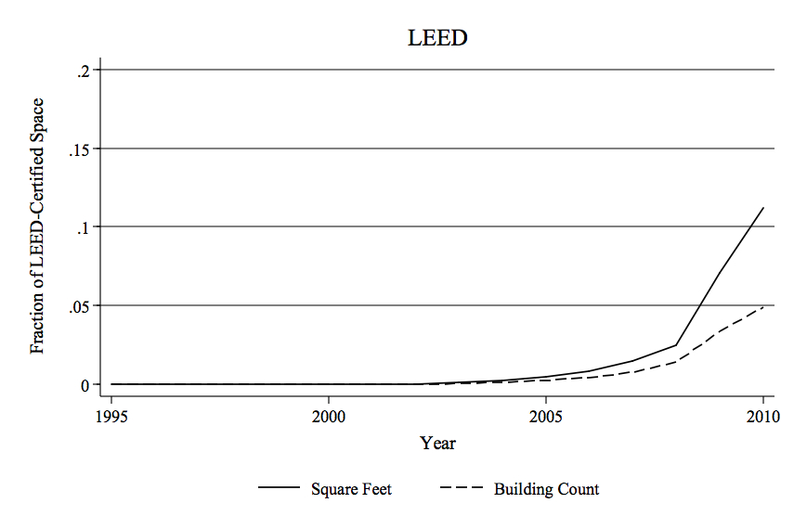

**B. Composition of LEED-Certified Commercial Space**

**Exhibit 2**

**Descriptive Statistics**

**(374 LEED Certified Buildings and 582 Conventional Buildings)**

|  |  |  |
| --- | --- | --- |
|  | LEED Certified | Control Sample |
| Rent | 28.15 | 29.23 |
| ($ per sq.ft.) |  |  |
| Occupancy Rate | 83.73 | 87.38 |
| (percent) |  |  |
| Effective Rent | 23.83 | 25.05 |
| ($ per sq.ft.) |  |  |
| Energy Star | 86.88 | 37.35 |
| (1 = yes) |  |  |
| Building Class |  |  |
| Class A | 83.09 | 66.34 |
| (percent) |  |  |
| Class B | 16.91 | 33.66 |
| (percent) |  |  |
| Building Size | 522.40 | 495.10 |
| (thousands sq.ft.) |  |  |
| Typical Floor Area | 27.10 | 45.60 |
| (thousands sq.ft.) |  |  |
| Age | 22.33 | 26.93 |
| (years) |  |  |
| Renovated | 41.40 | 31.90 |
| (percent) |  |  |
| Distance to Transit | 0.30 | 0.43 |
| (miles) |  |  |

**Exhibit 3**

**Survey Results**

**Percentage of Improvements Related to Sustainability**

**Exhibit 4**

**Survey Results**

**Major Improvements During Retrofit**

**Exhibit 5**

**Survey Results**

**Expected Payback in Years on Sustainability-Related Improvements**

**Exhibit 6**

**Survey Results**

**Current Rent Level Compared to Average Rent for Similar But Non-LEED B Buildings**

**Exhibit 7**

**Rents and Vacancy Rates of LEED Sample and Control Sample**

**(Q1 2000 – Q1 2011)**

**Panel A. Rental Levels Prior To and After Renovation**

**Panel B. Occupancy Rates Prior to and After Renovation**

**Exhibit 8**

**Aggregate Rents and Vacancy Rates of LEED Sample and Control Sample**

**(By Market, Q1 2011)**

**Panel A. Rental Levels**

**Panel B. Occupancy Rates**

**Exhibit 9**

**Regression Results**

**LEED Ratings and Rents**

|  |  |  |  |
| --- | --- | --- | --- |
|  | (1) | (2) | (3) |
| LEED Certified |  | 0.071*** | 0.052** |
| (1 = yes) |  | [0.023] | [0.023] |
| Energy Star |  |  | 0.056*** |
| (1 = yes) |  |  | [0.020] |
| Building Class |  |  |  |
| Class A | 0.115*** | 0.110*** | 0.101*** |
| (1 = yes) | [0.022] | [0.022] | [0.022] |
| Building Size | -0.022 | -0.024 | -0.032 |
| (log) | [0.020] | [0.020] | [0.020] |
| Typical Floor Area | 0.030 | 0.034* | 0.037* |
| (log) | [0.020] | [0.019] | [0.019] |
| Age | 0.002 | 0.002 | 0.002 |
| (years) | [0.001] | [0.001] | [0.001] |
| Age2 | -0.000* | -0.000** | -0.000** |
| (years) | [0.000] | [0.000] | [0.000] |
| Distance to Transit | -0.112*** | -0.110*** | -0.106*** |
| (miles) | [0.015] | [0.015] | [0.015] |
|  |  |  |  |
| City-Fixed Effects | Y | Y | Y |
|  |  |  |  |
| Constant | 2.941*** | 2.887*** | 2.932*** |
|  | [0.279] | [0.278] | [0.277] |
| Observations | 970 | 970 | 970 |
| R-squared | 0.636 | 0.640 | 0.643 |
| Adj R2 | 0.629 | 0.632 | 0.635 |

Standard errors in brackets

*** p<0.01, ** p<0.05, * p<0.1

**Exhibit 10**

**Regression Results**

**Green Ratings and Effective Rents**

|  |  |  |  |
| --- | --- | --- | --- |
|  | (1) | (2) | (3) |
| LEED Certified |  | 0.091*** | 0.058 |
| (1 = yes) |  | [0.035] | [0.037] |
| Energy Star |  |  | 0.098*** |
| (1 = yes) |  |  | [0.031] |
| Building Class |  |  |  |
| Class A | 0.155*** | 0.147*** | 0.132*** |
| (1 = yes) | [0.034] | [0.034] | [0.034] |
| Building Size | 0.035 | 0.033 | 0.019 |
| (log) | [0.032] | [0.032] | [0.032] |
| Typical Floor Area | 0.033 | 0.038 | 0.044 |
| (log) | [0.031] | [0.031] | [0.030] |
| Age | 0.007*** | 0.007*** | 0.007*** |
| (years) | [0.002] | [0.002] | [0.002] |
| Age2 | -0.000** | -0.000*** | -0.000*** |
| (years) | [0.000] | [0.000] | [0.000] |
| Distance to Transit | -0.135*** | -0.132*** | -0.126*** |
| (miles) | [0.023] | [0.023] | [0.023] |
|  |  |  |  |
| Constant | 1.907*** | 1.839*** | 1.915*** |
|  | [0.436] | [0.435] | [0.434] |
|  |  |  |  |
| City-Fixed Effects | Y | Y | Y |
|  |  |  |  |
| Observations | 952 | 952 | 952 |
| R-squared | 0.487 | 0.491 | 0.496 |
| Adj R2 | 0.477 | 0.480 | 0.485 |

Standard errors in brackets

*** p<0.01, ** p<0.05, * p<0.1

**Exhibit 11**

**Energy Reduction Strategies and Costs**

**(**[**www.DavisLangdon.com**](http://www.DavisLangdon.com) **-- see research reports)**

**Panel A. Energy Costs and Energy Star Scores**

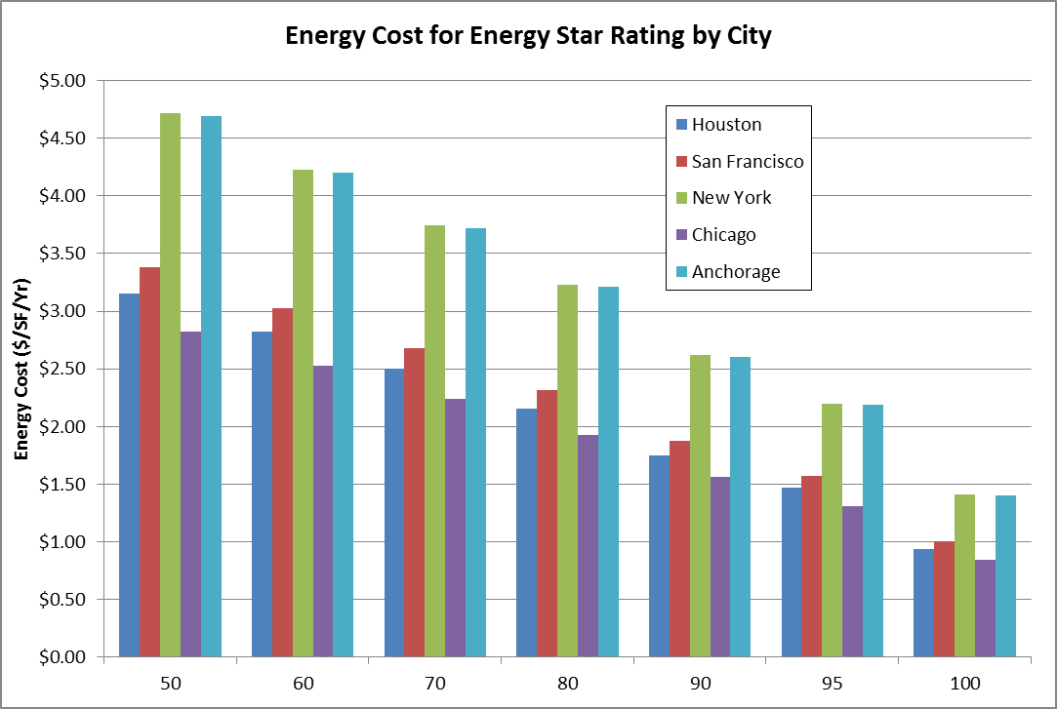

**Panel B. Reduction Strategies**

|  |  |  |
| --- | --- | --- |
| Strategy | KBtu/SF/Yr  (Reduction) | Cost/SF |
| Plug load | 6 -15 | Minor |
| Lighting | 6 - 8 | $3 - $5 |
| Ventilation | 4 - 5 | $2 - $5 |
| Cooling | 10 - 15 | $3 - $7 |
| Heating | 3 - 10 | $1 - $2 |
| **Total** | **30 - 50** | **$10 - $20** |

1. Source: The CoStar Group, 2010 study by one of the authors.
2. For example, one study on Australia, by Miller and Buys (2008), examined the benefits of retrofits from the perspective of tenants in a large office property. They found positive sentiments that green retrofits would continue and were well received by tenants. No study we are aware of has examined the economics of retrofits based on a broadly selected sample.
3. CBRE. 2010. "Locational Preferences of Central London Occupiers," CBRE Research.
4. See “Corporate Occupier Sustainability Perspectives – 2012” by Corenet Global, CBRE and the University of San Diego.
5. Jones Lang LaSalle. 2009. The Performance Measurement Challenge.
6. British Land. 2010. “Achieving More Together: Corporate Responsibility Summary Report 2010.”
7. See http://www.davislangdon.com/Global/.
8. For example, Fireman’s Fund charges about 5 percent lower insurance premiums for such buildings.
9. See https://www.globalreporting.org/ and http://www.gresb.com
10. For example, LEED (global), BREEAM (global), Energy Star (US), CASBEE (Japan), HK BEAM (Hong Kong), Green Star (Australia), HQE (France) and DGNB (Germany).