House Prices and Economic Growth

Norman Miller
University of Cincinnati

Liang Peng∗
University of Colorado at Boulder

Abstract

Applying recent advances in panel data econometrics that help control for unobserved macro economic factors and spatially correlated error terms, we measure the effects of house price changes on economic growth using a rare data set that covers all 379 metropolitan statistic areas (MSAs) in the U.S. from the first quarter of 1983 to the fourth quarter of 2005. We find that 10% increase in house prices is associated with about 1% increase in Gross Metropolitan Product in the same quarter, and lagged house prices have no impact on economic growth, which seems to suggest that the economy “capitalizes” good news in house price appreciation immediately.

JEL classification: E23, E24, E32, R11

Key words: housing market, common correlated effects estimators, CD test, Granger causality

© 2006 by Norman Miller, Liang Peng. Preliminary draft and do not quote please.
House Prices and Economic Growth

Abstract

Applying recent advances in panel data econometrics that help control for unobserved macro economic factors and spatially correlated error terms, we measure the effects of house price changes on economic growth using a rare data set that covers all 379 metropolitan statistic areas (MSAs) in the U.S. from the first quarter of 1983 to the fourth quarter of 2005. We find that 10% increase in house prices is associated with about 1% increase in Gross Metropolitan Product in the same quarter, and lagged house prices have no impact on economic growth, which seems to suggest that the economy “capitalizes” good news in house price appreciation immediately.

JEL classification: E23, E24, R11

Key words: housing market, common correlated effects estimators, CD test, Granger causality
House Prices and Economic Growth

I. Introduction
There seems to be a consensus among economists and policy makers that house prices have been playing an important role in fueling the growth of the economy. For instance, many believe that the strong housing market during the crash of the stock market in 2001 may have helped save the US economy from a more serious recession, and recent cooling of the housing market generates concerns regarding a possible slow down of the economy. Indeed, many economic theories indicate that house price changes should have real effects on the economy. For instance, Friedman’s well known permanent income hypothesis suggests that people would change their consumption if house price changes affect their estimates of their permanent wealth. Recently, economists propose more mechanisms through which house price changes may affect the economy. For example, Aoki, Proudman and Vlieghe (2002), Lustig and Nieuwerburg (2004), and Ortalo-Magné and Rady (2004) argue that house price increases may help relax borrowing constraints and thus increase consumption (the collateral effect). Furthermore, Li and Yao (2005) argue that the effect of house price changes may not be uniform across individual households. These theories shall apply to both closed and open economies, including regional economies.
Empirical evidence of the consumption effect of house prices is generally consistent with theories. Early evidence includes the positive effect of house price increases on consumption found by Bhatia (1987). Engelhardt (1994), Engelhardt (1996), and Sheiner (1995), among others, find that house price changes may affect young renters’ as well as homeowners’ saving behavior. Recently, a fast growing literature shows that the wealth effect of housing is not only statistically significant, but also probably larger than the wealth effect from the stock market (see Benjamin, Chinloy and Jud (2004), Case, Quigley and Shiller (2001), Kishor (2004), and Lettau and Ludvigson (2003), Bostic, Gabriel and Painter (2006), Carroll, Otsuka and Slacalek (2006), Slacalek (2006), among others). Furthermore, Campbell and Cocco (2004) show that the aggregate effect on consumption varies across different age groups and there is evidence supporting both the wealth effect and the collateral effect. Up to now, the only evidence we know of that shows no aggregate effect of house price changes on the economy is Phang (2004).
While the literature on the wealth effect of house prices provides important insights into the economic implications of housing markets, the relation between house price and economic growth, which is related to but also distinguished from the wealth effect of house prices, is rarely analyzed despite its important policy implications. For example, to our knowledge, there is no study that measures the house price elasticity of economic growth, or the timing of such effect. The wealth effect may only partially contribute to the impact of house prices on economic growth, and there are likely other mechanisms through which house prices directly affect economic production. For instance, increasing house prices may indicate excess demand for housing, which in turn leads to more construction and thus directly increases economic production. As a result, it is important to analyze the direct effects of house prices on economic growth. This paper hopes to contribute to the literature by measuring the statistical and economic significance of the direct effects of house prices on economic growth, as well as the timing of such effects.
When measuring the effect of house price changes on economic growth, it is important to control for unobserved economic variables that might correlate with house price changes and also help determine economic growth. Failing to control for such variables would bias the estimate of the coefficient of house prices and thus the results would be misleading (see, e.g. Poterba (2000) in the context of stock market wealth effect which seems also applicable on housing effects and Campbell and Cocco (2004) for more discussions). This problem, to our knowledge, is rarely well addressed in the literature, including the empirical work discussed earlier regarding the wealth effect of house prices. A main reason has been the lack of suitable econometric tools.
Pesaran (2006) proposes a novel multifactor error structure approach to effectively control for unknown variables that might correlate with dependent variables in linear regressions. The corresponding estimator is called Common Correlated Effects (CCE) estimators. In a panel data setting, the unobserved factors and the individual-specific errors are allowed to following arbitrary stationary processes, and the approach works without requiring estimating the unobserved variables or the number of them. Such a new approach allows us to estimate the effect of house prices on economic growth potentially more accurately and with unobserved variables controlled, which helps distinguish this paper from most empirical papers in the literature.
A large cross section in a panel data set is necessary to utilize the approach proposed by Pesaran (2006). Fortunately, we are able to get access to a rare data set that covers all 379 (as defined in 2006) metropolitan statistic areas (MSAs) in the U.S. from the first quarter of 1983 to the fourth quarter of 2005. Being able to combine the novel approach with a suitable and rare data set enables this paper to provide novel insights into the relation between house prices and economic growth.
We find statistically significant effects of house price changes on Gross Metropolitan Product (GMP) growth. Economically, the average relationship suggests that a 10% increase in house prices would be associated with a 1% increase in GMP. Moreover, the CCE estimators are always lower than “naïve” estimators that do not control for the unobserved common factors that help determine GMP growth. This shows the importance of controlling for such factors, and that a simple regression of GMP growth on house price changes may provide upward biased measure of the effects of house price changes.
We then study the timing of the economic effects from house price changes. In a dynamic panel setting, we regress GMP growth on lagged house price changes and other control variables. We find no effect from lagged house price changes. A formal test does not reject the null hypothesis that lagged house price changes have no effect on MSA economic growth.
Overall, our empirical results seem to suggest that, house price changes have significant immediate effects on economic growth, but the effects are short lived. This seems to suggest that the economy fully “capitalize” the good news associated with increasing house prices quickly. It appears reasonable to expect that part of the immediate effect relates to the effect of house price changes on the business of home builders and real estate agencies. Of course, other interpretations might not be rejected until more theoretical and empirical research is conducted.
This rest of this paper is organized as follows. Section 2 describes the data. Section 3 discusses the model and estimation of the effects of house price changes on GMP growth at the MSA level. Section 4 analyzes the timing of the effects using a dynamic model with two way fixed effects. Section 5 concludes.

II. Data
Our analysis utilizes a large panel data set that comprises five MSA level variables observed quarterly from 1983:1 to 2005:4 for each of all the 379 MSAs in the U.S. (as defined in 2006), and two national level time series in the same sample period are also used in part of the analysis. The five MSA level variables are per capita GMP, single-family house price index, average household income, population, and unemployment rate. The two national level time series are national average 30-year fixed-rate mortgage rate, and the SP500 index. GMP and unemployment rates are provided by the Bureau of Labor Statistics (BLS); population data are provided by the Bureau of the Census (BOC); home price indices are transaction based and provided by the Office of Federal Housing Enterprise Oversight (OFEHO); the average mortgage rates are provided by the HSH associates; and the SP500 index is from CRSP.
While our analysis focuses on the relation between per capita GMP and house prices, we include average household income, population, and unemployment rate as important MSA level control variables. Theories, such as Ortalo-Magné and Rady (2004), suggest that income shocks might affect not only the economy but also the housing market. Changes in population help capture migration, which can affect the per capita output in a MSA, for migration may affect not only the population level but also the productivity of the labor force of the MSA. Migration may also affect the dynamics of house prices (see, e.g. Gabriel, Mattey and Wascher (1999) for direct evidence). Changes in unemployment rate may capture changes in the magnitude of frictions in the labor market or transitions of the economy, which relates to relocation of labor force and affects both the economy and the housing market. In additional to MSA level control variables, we use the average mortgage rate and the SP500 index as national level control variables. We show that the two national level control variables are not sufficient in capturing all common factors that help determine economic growth; therefore, the new approach by Pesaran (2006) is important.
We process the data by first converting nominal terms into real terms, and then calculating the first order differences of log values of the variables. We use CPI to adjust for inflation and obtain real terms for per capita GMP, house price index, average household income, and the SP500 index. We choose to work on the first order differences of log values the variables (log differences) instead of the original variables or their logs (level) because all OFHEO house price indices are set to be 100 in 1995:1, and thus house price levels are not comparable across MSAs.
Figures 1 to 3 illustrate the temporal behavior of the variables. Figure 1 plots the time series of the first order differences of the log of house price indices in quarterly frequency. Figure 2 plots the time series of the SP500 index (normalized to be one in 1990:1) and the average 30-year fixed-rate mortgage rate (percentage points). Figure 3 plots the 25%, 50%, and 75% percentiles of across MSA distributions of per capita GMP (in thousand dollars), average household income (in dollars), population (thousand people), and unemployment rate (percentage points) over time.
Since our analysis uses differences instead of levels, we report some important statistics on the log differences of the seven variables in table 1. When we calculate statistics for MSA level variables, or correlations between a MSA level variable and a national level variable, we also provide t-statistics from testing null hypotheses that means of the across-MSA distributions of the statistics are zero. It is interesting to notice that the correlation between house price changes and GMP growth rates is significantly positive, which is consistent with a positive effect of house prices on economic growth. However, GMP growth rates and house price changes respectively significantly relate to the household income growth rate, population growth rate, mortgage rate growth rate, and stock price appreciation, which may indicate the existence of simultaneity. Furthermore, the GMP growth rate significantly relates to all proposed control variables, which justifies the importance of the control variables in measuring the impact of house price changes on GMP growth rates. Another interesting observation is that all MSA-level variables are serially correlated, which may suggest possible temporal relation between house price changes and GMP growth.
Our MSA level data have important advantages. In additional to widely understood benefits of panel data (e.g. allowing for control of individual heterogeneity and having more power due to a large number of observations), the large cross section in our panel of MSAs allows us to benefit from the novel approach by Pesaran (2006), so that we are able to control for unobserved macro economic variables. Moreover, all MSAs are in the United Sates, and thus are homogenous in the sense that they are subject to the similar if not identical monetary policy, political environment, legal context, tax code, and financial market conditions. As a result, MSA-level data seem superior to international data such as those used by Case, Quigley and Shiller (2001), because the economic effects of house prices may differ with a different economic, legal and tax environment, and such an environment is difficult to control in international data. Finally, the sample period in this paper covers both economic expansions and recessions so it does not seem to be biased.
However, our analysis at the MSA level also has caveats, which are mainly regarding how to interpret the results. It would be reasonable to assume that house price changes would affect households’ economic behavior, which in turn will affect the economy of the MSA where the household lives and other MSAs, for MSA economies are integrated. As a result, there would be cross sectional dependence in idiosyncratic errors, which, fortunately, is accommodated by the approach of Pesaran (2006). Nonetheless, readers should be cautious that our results should be interpreted as the effect of house prices on the growth of an open economy.

III. House Prices and Economic Growth
We use the following linear model to analyze how house price changes may affect the economic growth of MSAs:
,
where and are respectively the log difference of the Gross Metropolitan Product (GMP) and the log difference of the house price index from quarter to for MSA , is a vector of MSA level variables that may help determine the GMP, including log differences of population, average household income, and unemployment rate; and is the error term. The error term is assumed to capture the common unobserved factors as well as possible spatial effects:
,
Where is a vector of unknown common effects, and are the idiosyncratic errors assumed to be distributed independently of and and across MSAs.
The model described by equations and is reasonably general and flexible. First, it is apparent that the individual specific intercept term captures unobserved heterogeneity in GMP growth that remains constant across time for each MSA but differs across MSAs. Second, the model controls for local variables that change both across MSAs and time periods that may affect economic growth in a MSA. Third, it allows us to control for macro economic variables, despite their being possibly unobserved, that affect the economic growth in all MSAs. Finally, the model is flexible enough to allow each MSA to respond to the common factors differently. As a result, factors that affect some but not all MSAs are also controlled since the MSAs that are not affected by these factors simply have zero coefficients.
We use the CD (Cross-section Dependence) test of Pesaran (2004) to study the importance of including the vector of unknown common effects in the error term of the above model. The test applies to panel data sets with short and large , which is our case, and does not require estimation of the common factors or any priori specification of a connection matrix between MSAs. Since some MSAs in our data set have missing data for some variables, we essentially have an unbalanced panel. Therefore, we construct the test as follows. Following Pesaran (2004), denote by the set of dates over which time series observations on and observed dependent variables are available, and by the number of the elements in the set. We first compute the OLS residuals based on full set of time series of observations for each MSA, using three variations of equation respectively. For each variation/specification, we calculate the CD statistic as follows. Denote the residuals by for , we compute the pair-wise correlations of and using the common set of observations in , and have
where
.
The CD statistic for the unbalanced panel is given by
.
Under the null hypothesis that , therefore ), .
The three specifications we use to conduct the CD tests are:
,
,
and
.
Apparently, in the specification of , we do not have any control variables; in the specification of , we include MSA level control variables; and in the specification of , we include both MSA level variables and two national level variables – the 30-year fixed rate mortgage rate and the S&P500 index level (both in log differences). The CD statistics are reported in table2, and they are 673.80, 387.22, and 382.22 for the three specifications, which provides strong evidence of the existence of cross section dependence of error terms. Furthermore, table 2 shows that the 30-year mortgage rate and the S&P500 index are not sufficient in capture all factors that affect MSAs. As a result, it is important to use the multifactor error structure of equations and to control for unobserved factors that affect all MSAs.
After the test, we estimate four different specifications of the model of equations and , which helps us check if our results are robust to the specification. The first specification is
,
which does not include the fixed effect (MSA specific intercept terms) or any local control variables. The second specification is
,
which includes MSA level control variables but does not include the fixed effect. The third specification is
,
which includes the fixed effect but not MSA level control variables. The fourth specification is
,
Which includes both the fixed effect and MSA level control variables.
We provide three different estimators for each of the four specifications. The first estimator is the simple OLS estimator, which we call the “naïve” estimator for it does not control for unobserved macro economic factors that help determine GMP growth or the endogeneity of the house price changes. The second estimator is the Common Correlated Effects estimators (CCE estimators) proposed by Pesaran (2006), which controls for unobserved macro economic factors. This estimator is constructed using regressions augmented with cross-sectional averages of all dependent and independent variables. The third estimator is the two-stage least square version of the CCE estimator. In constructing this estimator, we first follow Pesaran (2006) and use cross-sectional average of all dependent and independent variables to augment the regression equation, and then use lagged house price changes as instrumental variables to correct for possible bias caused by the endogeneity of house price changes. House price changes are serially correlated and it seems plausible to assume that lagged house price changes do not correlate with idiosyncratic error in current GMP growth; therefore, lagged house price changes are qualified instrumental variables.
The estimation results are reported in table 3. To summarize the results, first, the house price elasticity of GMP growth is statistically significant at 1% level and robust across all four specifications and all three estimators. Second, the CCE estimators are significantly lower than the naïve estimators. For example, in the fourth specification, which controls for both fixed effects and macro factors, the simple CCE estimator is 0.048 and the two-stage least square CCE estimator is 0.102, while the naïve estimator is 0.121. Third, it makes big difference whether to control for the endogeneity of house price changes. The two-stage CCE estimators are significantly higher than the simple CCE estimators, which seems to imply that there is negative correlation between house price changes and the idiosyncratic error of the GMP growth, so that estimators would be downward biased if the endogeneity is not controlled by the two-stage least squares. Finally, CCE regressions have much higher R squares than naïve regressions, which is not surprising but nonetheless shows the explanatory power of the cross sectional averages of the dependent and independent variables.
Economically, the results in table 3 seem to suggest that house price changes are strongly correlated with GMP growth. A 10% increase in the house price would be associated with about 1% of GMP growth in the same quarter. However, it is worth noting that, if not controlling for macro factors, this effect would be estimated with upward bias and would be 1.2%.
To check if the results are robust across time, we split the sample period into before 1994 period and after 1994 period. Results are reported in table 4. Using the two-stage least square CCE estimators, we find that the house price elasticity of GMP growth is statistically significant at 1% level in both sub sample periods. Interestingly, the elasticity is lower in the 1995-2005 period than the before 1994 period, which might indicate that the effect of house price changes on economic growth is time variant.

IV. Timing of the Effect
There lacks evidence in the literature regarding the timing of the house price effect on economic growth. To study this issue, we estimate the following regression.
This regression can be interpreted as an equation in a bivariate panel VAR model with the GMP growth rate and the house price appreciate rate as the two endogenous variables, and it allows us to analyze if lagged house price changes affect the GMP growth. The lag order is chosen by running a preliminary VAR for each MSA, and about 95% of the MSAs have optimal (in the sense of AIC) lag order that is equal to or shorter than 4. This regression includes two way fixed effects, both MSA specific intercept terms and time specific intercept terms. We use them to control for two kinds of unobserved heterogeneity – the effects of variables that differ across MSAs but remain constant across time and variables that vary across time but affect all MSAs in each time period.
To obtain consistent estimators, we first subtract cross sectional averages from each variable to eliminate the time dummy, and then we take first order difference on both sides. It is well known that the differenced model can not be directly estimated, for the correlation between independent variables and the error term is not zero (see, e.g. Nickell (1981)). To overcome this problem, we use the instrumental variable approach of Holtz-Eakin, Newey and Rosen (1988), for this approach is appropriate for panels with large and shoart , which is our case, and this approach is valid even if there are unit roots and nonstationary variables (as a result of large ). Therefore, we do not conduct any unit root or cointegration tests. The instrumental variables we choose, following Holtz-Eakin, Newey and Rosen (1988), are lagged variables of house price changes.
Table 5 reports the regression results. None of the four lagged of house price changes is significant, while lagged GMP growth rates and the MSA level control variables are significant. This seems to suggest that lagged house price changes do not affect economic growth. To formally test this notion, we construct a test with the null hypothesis being all coefficients of the four lagged house price changes are equal to zero, which is essentially the Granger causality test in a VAR framework. The test statistic and the corresponding p value are also reported in table 5, which does not reject the null hypothesis.
The significant coefficients of house price changes in the contemporaneous regressions sharply contrast with the insignificant coefficients in the dynamic setting. This suggests that house prices might have immediate but short lived effects on economic growth. First, rising house prices, often accompanied by increasing trading volume and new construction, might have immediate effects on the construction sector and the income of real estate agents. Second, if the house price effect on consumption is long lasting, as suggested by papers such as Carroll, Otsuka and Slacalek (2006), our result may imply that economic production immediately reacts to possible consumption increase in the future and fully “capitalizes” it by raising production to such a level so that there is no more increase in next quarter. However, other interpretations can not be rejected without more theoretical and empirical analysis.

V. Conclusions
Applying recent advances in panel econometrics on a rare data set that covers all 379 MSAs in the U.S. over the period from 1983:1 to 2005:4, this paper is able to control for unobserved macro economic factors and provide unbiased estimation of the effects of local house price changes on MSA economic growth. The results show that it is important to control for unobserved factors, otherwise the effects of house price changes would be estimated with upward bias. Based on the CCE estimators, we find that, in the sample period, 10% increase in house prices is associated with 1% increase in GMP. This effect is statistically significant at 1% level for different specifications of the model.
Moreover, we find no evidence of the effects of lagged house price changes on GMP growth, which is demonstrated by not significant coefficients of lagged house price changes in a two way fixed effect panel model of GMP growth and a formal test that is essentially a Granger causality test. This result is interesting, for it might suggest that the economy fully “capitalize” good news of increasing house prices quickly, so the effect of house price changes on GMP growth is short lived.
References:

Aoki, Kosuke, James Proudman, and Gertjan Vlieghe, 2002, House Prices, Consumption, and Monetary Policy: a Financial Accelerator Approach, Bank of England Working Paper.
Bajari, Patrick, C. Lanier Benkardb, and John Krainer, 2005, House Prices and Consumer Welfare, Journal of Urban Economics 58, 474-487.
Benjamin, John D., Peter Chinloy, and G. Donald Jud, 2004, Real Estate Versus Financial Wealth in Consumption, Journal of Real Estate Finance and Economics 29, 341-354.
Bhatia, Kul B., 1987, Real Estate Assets and Consumer Spending, Quarterly Journal of Economics 102, 437-444.
Bostic, Raphael, Stuart Gabriel, and Gary Painter, 2006, Housing Wealth, Financial Wealth, and Consumption: New Evidence from Micro Data, University of Southern California Working Paper.
Campbell, John Y., and Joao F. Cocco, 2004, How Do House Prices Affect Consumption? Evidence from Micro Data, Harvard Institute of Economic Research Discussion Paper No. 2045.
Carroll, Christopher D., Misuzu Otsuka, and Jirka Slacalek, 2006, How Large is the Housing Wealth Effect? A New Approach, NBER Working Paper No. W12746.
Case, Karl E., John M. Quigley, and Robert J. Shiller, 2001, Comparing Wealth Effects: The Stock Market versus the Housing Market, Cowles Foundation Discussion Paper No. 1335.
Engelhardt, Gary V., 1994, House Prices and the Decision to Save for Down Payments, Journal of Urban Economics 36, 209-237.
Engelhardt, Gary V., 1996, House Prices and Home Owner Saving Behavior, Regional Science and Urban Economics 26, 313-336.
Gabriel, Stuart A., Joe P. Mattey, and William L. Wascher, 1999, House Price Differentials and Dynamics: Evidence from the Los Angeles and San Francisco Metropolitan Areas, Economic Review Federal Reserve Bank of San Francisco.
Holtz-Eakin, Douglas, Whitney Newey, and Harvey S. Rosen, 1988, Estimating Vector Autoregressions with Panel Data, Econometrica 56, 1371-1395.
Kishor, N. Kundan, 2004, Does Consumption Respond More to Housing Wealth than to Financial Market Wealth? If So, Why?, University of Washington Working Paper.
Lettau, Martin, and Sydney Ludvigson, 2003, Understanding Trend and Cycle in Asset Values: Reevaluating the Wealth Effect on Consumption, American Economic Review forthcoming.
Li, Wenli, and Rui Yao, 2005, The Life-Cycle Effects of Hous Price Changes, Unpublished manuscript.
Lustig, Hanno, and Stijn Van Nieuwerburg, 2004, Housing Collateral and Consumption Insurance Across US Regions, University of Chicago Working Paper.
Nickell, Stephen, 1981, Biases in Dynamic Models with Fixed Effects, Econometrica 49, 1417-1426.
Ortalo-Magné, François, and Sven Rady, 2004, Housing Transactions and Macroeconomic Fluctuations: A Case Study of England and Wales, Journal of Housing Economics 13, 287-303.
Pesaran, M. Hashem, 2004, General Diagnostic Tests for Cross Section Dependence in Panels, mimeo, University of Cambridge.
Pesaran, M. Hashem, 2006, Estimation and Inference in Large Heterogeneous Panels with Multifactor Error Structure, Econometrica 74, 967-1012.
Phang, Sock-Yong, 2004, House prices and aggregate consumption: do they move together? Evidence from Singapore, Journal of Housing Economics 13, 101-119.
Poterba, James M., 2000, Stock Market Wealth and Consumption, Journal of Economic Perspectives 14, 99-118.
Sheiner, Louise, 1995, Housing Prices and the Savings of Renters, Journal of Urban Economics 38, 94-125.
Slacalek, Jirka, 2006, What Drives Personal Consumption? The Role of Housing and Financial Wealth, German Institute for Economic Research Working Paper.

Table 1 Data Summary
Panel A summarizes the respective mean, median, standard deviation for the time series of first order differences of the log values of per capita GMP (GMP), home price index (HP), population (PO), average household income (HI), unemployment rate (UR), 30-year fixed rate mortgage rate, and the SP500 index. Panel B reports their 1 to 4-quarter autocorrelations. Panel C reports correlations among the variables. For statistics involving MSA level variables (GMP, HP, PO, HI, UR), the reported numbers are across MSA averages. For these variables, we also report the t-statistics with the null hypotheses being that the distributions of the variables have zero means. * denotes significance at the 5% level and ** at the 1% level.
 | GMP | HP | PO | HI | UR | MR | SP
Panel A. Mean, median, and standard deviation
Mean | **0.447% | **0.461% | **0.281% | **0.305% | **-0.092% | -0.785% | 1.472%
Median | **0.452% | **0.470% | **0.282% | **0.321% | **-0.476% | -1.241% | 1.563%
Sta. Dev. | **1.264% | **2.131% | **0.194% | **1.288% | **7.382% | 5.768% | 6.831%
Panel B. Autocorrelation
1 quarter | **0.292 | *-0.043 | **0.955 | **-0.058 | **0.230 | -0.093 | 0.002
2 quarter | **0.247 | **0.182 | **0.837 | **0.123 | **0.118 | -0.055 | 0.064
3 quarter | **0.082 | **0.220 | **0.678 | **-0.121 | **0.067 | 0.127 | 0.146
4 quarter | **0.066 | **0.204 | **0.532 | **0.205 | *-0.019 | -0.187 | 0.057
Panel C. Correlation
GMP | 1 | **0.211 | **-0.060 | **0.418 | **-0.229 | 0.007 | **0.135
HP |  | 1 | **0.102 | **0.168 | **-0.029 | **-0.056 | **0.074
PO |  |  | 1 | **-0.049 | 0.016 | 0.007 | **0.021
HI |  |  |  | 1 | **-0.112 | **0.079 | **0.181
UR |  |  |  |  | 1 | **-0.069 | **-0.109
MR |  |  |  |  |  | 1 | -0.147
SP |  |  |  |  |  |  | 1

Table 2 Cross Section Dependence Tests
This table reports the cross section dependence tests for three different specifications of a linear model in which the log difference of GMP is regressed on the log difference of the house price index for the corresponding metropolitan area.
Specification 1:
CD test value: 673.80
Specification 2:
CD test value = 387.22
Specification 3:
CD test value = 382.22

Table 3 House Price Changes and Economic Growth
This table reports three different estimators for four different specifications of the following linear model:
where and are the log differences of the GMP and the house price index from quarter to for MSA ; is a vector of MSA level variables, including log differences of population, average household income, and unemployment rate; is a vector of unknown common effects; and are the idiosyncratic errors. The first specification does not include the MSA fixed effect or control variables; the second specification includes control variables but not the MSA fixed effect; the third specification includes the MSA fixed effect but not control variables; and the fourth specification includes both the MSA fixed effect and control variables. Naïve estimators are simple OLS estimators; CCE estimators are Common Correlated Effects estimators of Pesaran (2006), 2-stage CCE are the two-stage least square version of the CCE estimators using lagged house price changes as instrumental variables. * denotes significance at the 5% level and ** at the 1% level.
Estimator | HP | PO | HI | UR | Fixed effect | R2
Specification I
Naïve | **0.108  [0.004] |  |  |  | No | 0.04
CCE | **0.042  [0.004] |  |  |  | No | 0.27
2-stage CCE | **0.102  [0.009] |  |  |  | No | 0.27
Specification II
Naïve | **0.115  [0.004] | **-0.210  [0.056] | **0.263  [0.008] | **-0.029  [0.001] | No | 0.20
CCE | **0.039  [0.004] | **-0.141  [0.021] | **0.146  [0.006] | **-0.027  [0.001] | No | 0.35
2-stage CCE | **0.069  [0.011] | **-0.168  [0.022] | **0.144  [0.066] | **-0.027  [0.001] | No | 0.35
Specification III
Naïve | **0.107  [0.04] |  |  |  | Yes | 0.03
CCE | **0.039  [0.004] |  |  |  | Yes | 0.27
2-stage CCE | **0.088  [0.014] |  |  |  | Yes | 0.27
Specification IV
Naïve | **0.121  [0.004] | **-0.405  [0.081] | **0.261  [0.008] | **-0.030  [0.001] | Yes | 0.20
CCE | **0.048  [0.005] | *-0.332  [0.131] | **0.145  [0.009] | **-0.027  [0.001] | Yes | 0.36
2-stage CCE | **0.102  [0.017] | **-0.405  [0.142] | **0.141  [0.009] | **-0.027  [0.001] | Yes | 0.36

Table 4 House Price Changes and Economic Growth: Sub-sample Analysis
This table reproduces the three estimators for the fourth specification in table 3 for two sub periods: the period from 1983 to 1994 and the period from 1995 to 2005. * denotes significance at the 5% level and ** at the 1% level.
Estimator | HP | PO | HI | UR | Fixed effect | R2
1983 to 1994
Naïve | **0.080  [0.007] | 0.034  [0.064] | **0.238  [0.010] | **-0.039  [0.002] | Yes | 0.19
CCE | **0.060  [0.007] | *0.155  [0.060] | **0.163  [0.013] | **-0.030  [0.002] | Yes | 0.29
2-stage CCE | **0.083  [0.026] | 0.091  [0.087] | **0.164  [0.014] | **-0.030  [0.002] | Yes | 0.28
1995 to 2005
Naïve | **0.139  [0.005] | **-0.463  [0.044] | **0.261  [0.006] | **-0.025  [0.001] | Yes | 0.20
CCE | **0.023  [0.005] | **-0.501  [0.038] | **0.126  [0.006] | **-0.024  [0.001] | Yes | 0.40
2-stage CCE | **0.047  [0.017] | **-0.516  [0.040] | **0.125  [0.007] | **-0.024  [0.001] | Yes | 0.39

Table 5 Lagged House Price Changes and Economic Growth
This table reports the estimation of the following dynamic model
.
Time period fixed effects are eliminated by subtracting cross sectional means on both sides. The MSA fixed effects are eliminated by taking differences on both sides. The model is then estimated with instrumental variable regression to overcome the correlation between independent variables and the error term. * denotes significance at the 5% level and ** at the 1% level. The Granger Causality Test is essentially a test with the null hypothesis being that all coefficients of the four lagged house price changes (log differences) are all 0.
Variable | Estimator | Standard dev. | T value
HP lag1 | -0.004 | 0.006 | -0.69
HP lag2 | -0.011 | 0.009 | -1.25
HP lag3 | -0.011 | 0.009 | -1.26
HP lag4 | -0.009 | 0.006 | -1.51
GMP lag1 | **0.90 | 0.020 | 14.22
GMP lag2 | **0.116 | 0.013 | 9.19
GMP lag3 | -0.006 | 0.010 | -0.59
GMP lag4 | **-0.178 | 0.009 | -18.52
PO | **-0.949 | 0.273 | -3.48
HI | **0.038 | 0.006 | 6.85
UR | **-0.021 | 0.001 | -18.39
Granger Causality Test: Does HP Granger cause GMP
F statistic | 1.624
P value | 0.16

Figure 1 Home Price Appreciation Rates
This figure plots time series of log growth rates of OFEHO quarterly home price indices in all 379 MSAs in the U.S. from 1983:1 to 2005:4.
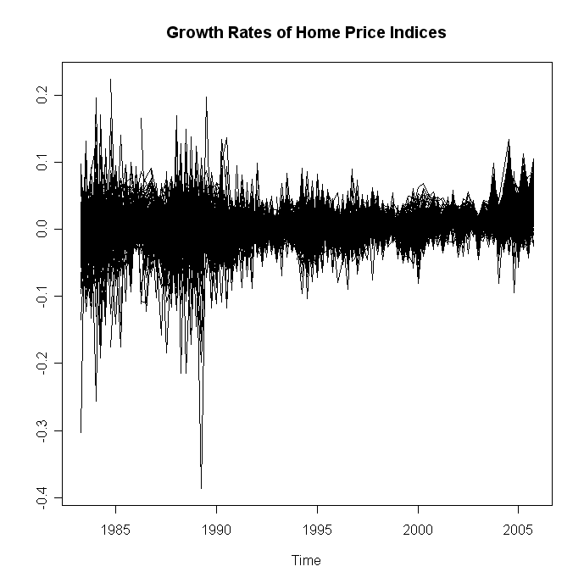

Figure 2 SP500 Index and 30-year Fixed-rate Mortgage Rate from 1983:1 to 2005:4
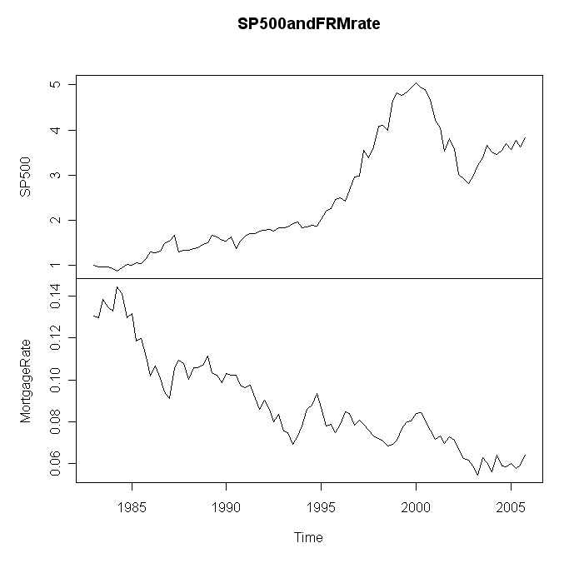
Figure 3
This figure visualizes the time series of 25%, 50%, and 75% percentiles of the per capita GMP (in thousand dollars), average household income (in dollars), population (in 1000 people), and unemployment rate (in percentage points) across all 379 MSAs in the U.S. from 1983:1 to 2005:4.
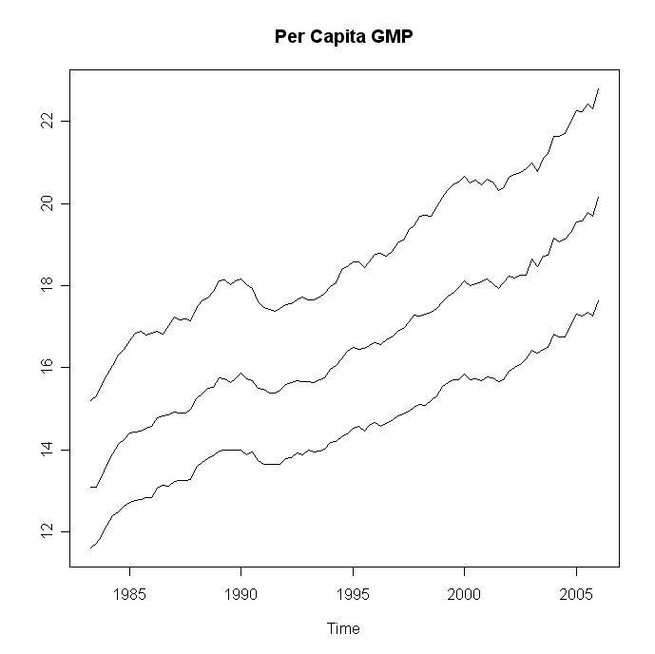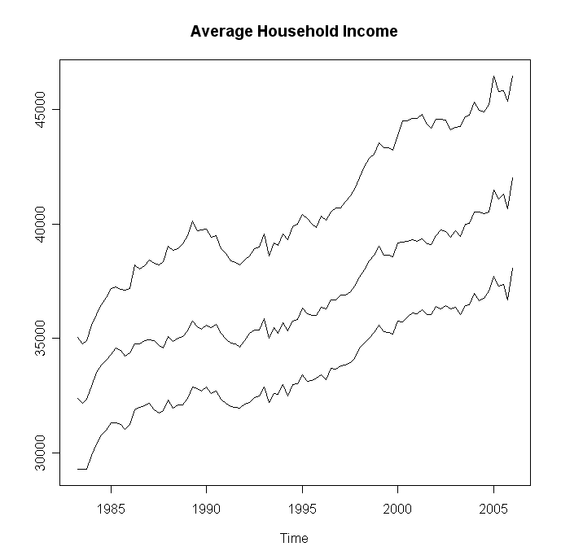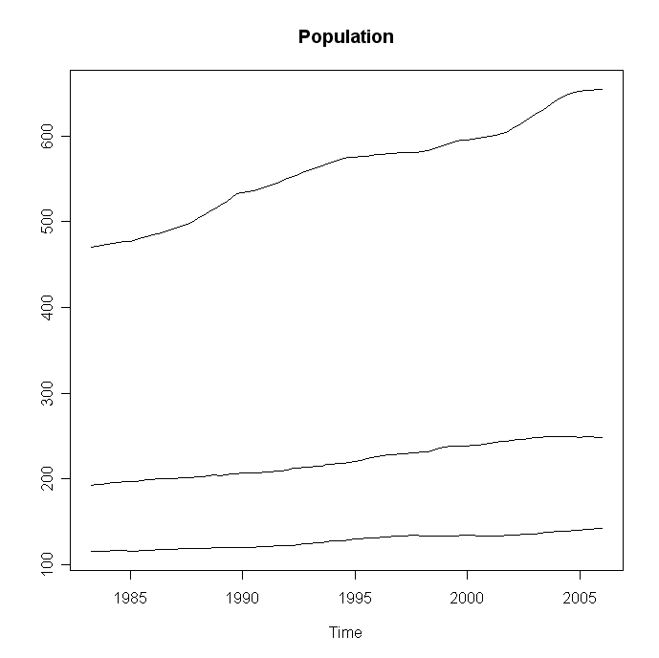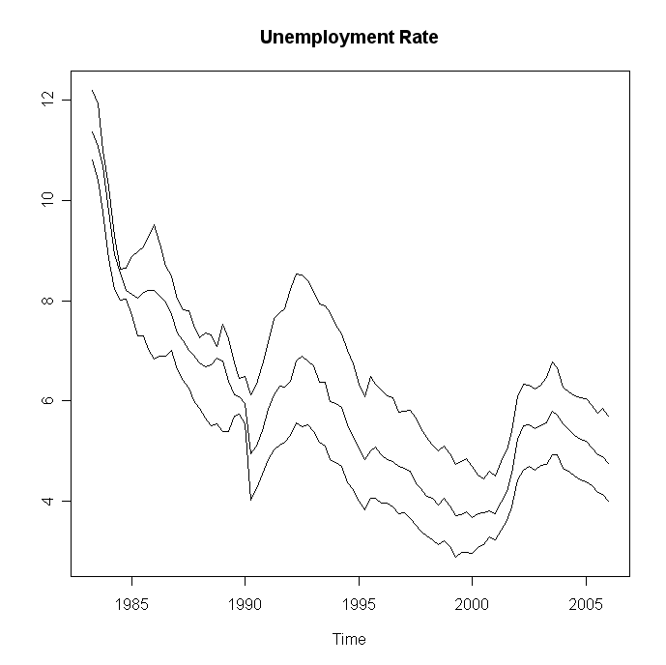

 Contact author: Liang Peng, Leeds School of Business, University of Colorado at Boulder, 419 UCB, Boulder, CO 80309-0419. Email: liang.peng@colorado.edu. Phone: (303)492-8215. Fax: (303)492-5962.
On September 26th, 2005 Alan Greenspan in a speech to the American Bankers Association re-iterated the important role of house prices in the current economy and suggested that housing may have fueled consumption over the past few years.
On December 12th 2006, Federal Reserve Open Market Committee stated that “Economic growth has slowed over the course of the year, partly reflecting a substantial cooling of the housing market.”
On the other hand, it is worth noting that a theory by Bajari, Patrick, C. Lanier Benkardb, and John Krainer, 2005, House Prices and Consumer Welfare, Journal of Urban Economics 58, 474-487. suggests no aggregate change in welfare due to price increases in the existing housing stock.
OFEHO house price indices are estimated with the repeat sale regression. Such indices control for time invariant attributes of houses that enter into the sample at least twice, and thus appear to be superior to median or mean sale prices. On the other hand, repeat sale regressions have some shortcomings and this is an active research area. In our analysis, we appreciate the large cross section and the long sample period of the OFEHO indices despite possible weakness of them.
We do not plot time series of house price indices per se for they are all set to be 100 at 1995:1, and thus such a time series plot does not visualize the temporal changes of the indices well.

